D2.2 - Documentation of the assessment of the AI model

and AQ thresholds



Other Information
Deliverable 2.2
Documentation of the assessment of the AI model and AQ thresholds analysis

Contributing Authors
Seraphim Kontos | Ariatotle University of Thessaloniki
Natalia Liora | Aristotle University of Thessaloniki
Konstantinos Diakakis | Aristotle University of Thessaloniki
Georgios Spyrou | Aristotle University of Thessaloniki
Dimitrios Melas | Aristotle University of Thessaloniki

Table of Contents
Executive Summary 8
1. Development of the AI Model 10
1.1. Introduction and Input Data 10
1.2. Preprocessing of Observations 11
1.3. AI Model, Training and Evaluation 12
1.3.1. Theoritical Backround 13
1.3.2. Model Design 13
1.3.3. Training Setup 14
1.4. Assessment of AI model 15
2. The Physics-Based Dispertion Model 17
2.1. Theoritical aspects 17
2.1.1 Theoritical Backround 17
2.1.2 Advection – Diffusion Equation 17
2.1.3 Advection-Only Approximation 18
2.1.4 From the 2D Advection Equation to the Implicit-Euler Linear System 18
2.2. Input of dispersion modeling 19
2.3. Workflow of dispersion modeling 20
2.3.1 The A Matrix Formation 20
2.3.2 Dispertion of Total Concentrations 20
2.3.3 Dispertion of Traffic-Attributed Concentrations 21
2.3.4 Final Traffic-Attributed and Background Concentrations 22
3 European Air Quality Index (EAQI) 23
Ethics and Data Protection 25
References 25

Table of Figures
Figure 1. Locations of air quality monitoring stations in Thessaloniki. Blue markers represent stations used for training with 2019 data, red markers indicate stations used operationally for AI-based CAMx forecast improvement, purple markers represent stations used in both training and operational phases, and yellow markers correspond to new stations installed under the MOBILAIR project.
Figure 2: Wind velocity components (u and v) on 24 July 2019 at 06:00 UTC, along with a simplified representation of the population of the transfer matrix A.
Figure 3: Prediction of total pollutant concentrations at the forecast hour (07:00 UTC - 24 July 2019), obtained from the dispersion of total pollutant concentrations at the current hour (06:00 UTC - 24 July 2019).
Figure 4: Calculation of the emission rate as the ratio of traffic emissions to total emissions for the current hour (06:00 UTC - 24 July 2019)
Figure 5: Calculation traffic-attributed pollutant concentrations at the current hour (06:00 UTC - 24 July 2019)
Figure 6: Prediction of traffic-attributed pollutant concentrations at the forecast hour (07:00 UTC - 24 July 2019), obtained from the dispersion of traffic-attributed pollutant concentrations at the current hour (06:00 UTC - 24 July 2019).
Figure 7: Calculation of traffic-attributed concentrations for the forecast hour (07:00 UTC, 24 July 2019), obtained by scaling the total predicted pollutant concentrations according to the ratio of predicted traffic-attributed concentrations to predicted total concentrations.
Figure 8: Calculation of final background concentrations for the forecast hour (07:00 UTC, 24 July 2019), obtained by subtracting the scaled traffic-attributed component from the total pollutant concentrations.
Figure 9: EAQI thresholds and associated health guidance, as defined by the European Environmental Agency (EEA)
Table of Tables
Table 1: Main hyperparameters of the hybrid CNN–LSTM model.
Table 2: Performance of LSTM-CNN vs raw CAMx forecasts for ${PM}_{10}$, ${PM}_{2.5}$ and ${NO}_{2}$ for Thessaloniki.

List of acronyms
Acronym | Explanation
LSTM | Long Short-Term Memory
CNN | Convolutional Neural Network
RNN | Recurrent Neural Network
WRF | Weather Research and Forecasting
CAMx | Comprehensive Air Quality Model with Extensions
AI | Artificial Intelligence
RMSE | Root Mean Squared Error
MAE | Mean Absolute Error
FAC2 | Factor of 2
IoA | Index of Agreement
EAQI | European Air Quality Index

Executive Summary
MOBILAIR is a project aimed at the development of an AI-powered mobile app that promotes eco-friendly urban mobility choices, providing real-time data on air quality and traffic conditions to encourage citizens for sustainable transport modes. Within this framework, the Aristotle University of Thessaloniki (AUTh) is responsible for the air quality forecasting component, which combines Artificial Intelligence with physics-based dispersion modelling to deliver improved, next-hour forecasts of PM₁₀, PM_{2.5}, and NO₂ concentrations across the Thessaloniki metropolitan area. The central objective of this work is to quantify the contribution of traffic emissions to total pollutant concentrations, providing the scientific basis for the app’s mobility recommendations.
The first component of the system is a hybrid Long Short-Term Memory – Convolutional Neural Network (LSTM–CNN) deep learning model, designed to correct systematic errors in the forecasts produced by the CAMx air quality model. Trained on a full year of 2019 data, the model integrates CAMx outputs, WRF meteorological variables (temperature, wind speed and direction, relative humidity), and ground-based monitoring station observations. Prior to training, the data underwent rigorous preprocessing: stations with more than one-third missing data were excluded, remaining gaps were filled using iterative Random Forest imputation, and temporal features—including cyclical time encodings and lagged concentration values—were engineered to capture daily and weekly pollution patterns.
Evaluation against raw CAMx forecasts demonstrated substantial improvements. The LSTM–CNN model reduced Root Mean Squared Error (RMSE) and Mean Absolute Error (MAE) by 65–80% across all pollutants and stations. Systematic bias was effectively eliminated, with corrected bias values near zero compared to large over- or underestimations by CAMx. Correlation coefficients in several cases more than doubled, the Index of Agreement consistently exceeded 0.80, and the Factor of Two (FAC2) metric rose from approximately 50–65% to above 85%, reaching nearly 100% at some stations.
The second component is a physics-based dispersion model that simulates the spatial transport of pollutants across Thessaloniki using a discretized advection equation solved with an implicit Euler scheme and first-order upwind differencing on the CAMx d03 nested domain (85×63 grid, 2 km resolution). Driven by WRF wind fields, the model disperses the AI-corrected concentrations from the current hour to produce spatially resolved forecasts for the next hour. Crucially, the dispersion model separates traffic-attributed concentrations from the total by scaling with the ratio of traffic (mobility) emissions to total emissions. This allows the system to estimate, for every grid cell and forecast hour, how much of the predicted pollution is directly attributable to road traffic and how much constitutes the background level unrelated to mobility.
The final outputs includes total, traffic-attributed, and background concentrations for PM10, PM2.5, and NO2, together with corresponding traffic contribution rates. These are further translated into the European Air Quality Index (EAQI), a six-level classification from “Good” to “Extremely Poor” defined by the European Environment Agency, making the results readily interpretable by citizens, stakeholders, and policymakers. By quantifying the specific role of traffic in urban air pollution, the system provides the evidence base needed to inform sustainable mobility decisions and support the broader goals of the MOBILAIR project.

Development of the AI Model

Introduction and Input Data
Air pollution continues to be a major concern in Thessaloniki, driven by high traffic volumes, industrial activities, and the city’s location. Accurate forecasts of air quality are essential for public health protection and informed decision-making. Numerical modeling has long been the primary tool for such forecasts, with the Weather Research and Forecasting (WRF) model providing meteorological inputs and the Comprehensive Air Quality Model with Extensions (CAMx) simulating pollutant concentrations. Despite their strengths, these models often show systematic errors and are limited in their ability to capture fine-scale differences within the city.
Within the MOBILAIR project, artificial intelligence (AI) methods were introduced to complement and improve the forecasts produced by CAMx. By integrating numerical model outputs with ground-based observations, the objective was to deliver corrected next-hour forecasts for key pollutants, thus reducing systematic biases and improving reliability.
The dataset used in this work consisted of three main components. First, CAMx outputs provided hourly concentrations of ${PM}_{10}$, ${PM}_{2.5}$, and ${NO}_{2}$, forming the baseline forecasts to be corrected. Second, meteorological data were extracted from WRF outputs, including variables such as temperature, wind speed and direction, and relative humidity. These parameters are critical for pollutant dispersion and transformation processes. Third, air quality monitoring stations across Thessaloniki supplied hourly observations of pollutant concentrations, which served as the reference data for training and evaluation of the AI models.
The focus of the study was the Thessaloniki metropolitan area during 2019, providing a complete year of data for development and assessment. Some monitoring stations were used only during the training phase with 2019 data, others are included in the operational application of the AI corrections, and several contribute to both processes. In addition, the MOBILAIR project has installed new stations, which will expand spatial coverage and provide additional datasets.
In summary, combining CAMx forecasts, WRF meteorological data, and station observations created a well-rounded dataset that links model outputs with real-world measurements. This dataset provided the basis for developing an AI system aimed at correcting systematic errors in CAMx and producing more reliable next-hour air quality forecasts for Thessaloniki.

Preprocessing of Observations
Before the observational data could be used for training and evaluation of the AI models, it was necessary to apply a series of preprocessing steps. Preprocessing is a critical stage in any machine learning pipeline, particularly in environmental applications, because raw monitoring data often suffer from missing values or sensor errors. If these issues are not treated carefully, they may lead to biased models, increased variance in predictions, or unstable results. In time series forecasting, missing data are especially problematic because models rely on temporal continuity, and large gaps can break this structure.
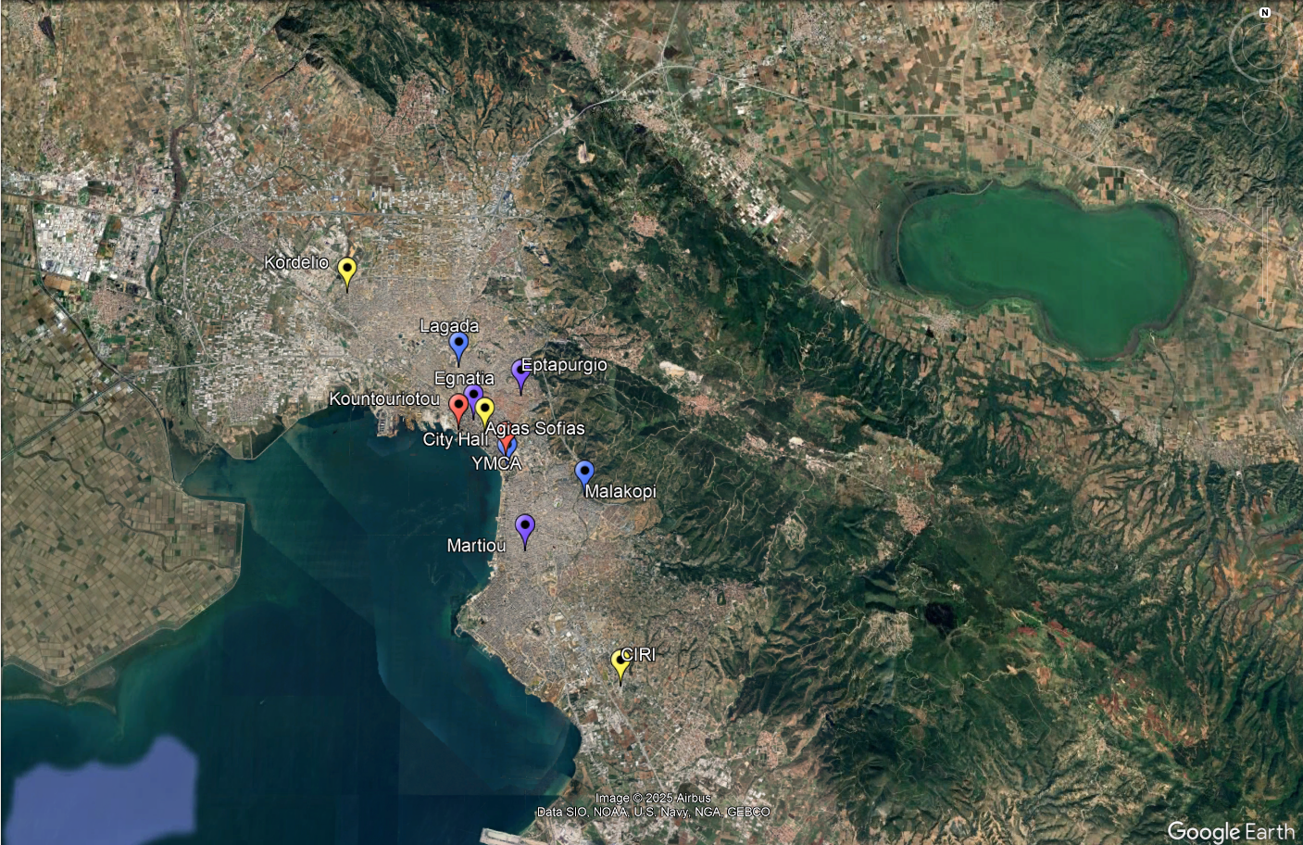
The first step involved filtering monitoring stations to ensure sufficient data coverage. Only stations with less than 1/3 missing data for the year 2019 were included. This type of completeness threshold is commonly used in air quality studies, as it balances the need for spatial coverage with the requirement for robust, reliable time series.
Figure 1: Locations of air quality monitoring stations in Thessaloniki. Blue markers represent stations used for training with 2019 data, red markers indicate stations used operationally for AI-based CAMx forecast improvement, purple markers represent stations used in both training and operational phases, and yellow markers correspond to new stations installed under the MOBILAIR project.
For the remaining stations, missing hourly values were reconstructed using iterative imputation with Random Forests. Instead of applying simple interpolation or mean substitution, which may oversimplify temporal variability and underestimate extremes, the Random Forest approach allows for more realistic reconstructions. It works by predicting missing values using relationships with other variables and observations, capturing both linear and nonlinear dependencies. This method is conceptually similar to the missForest algorithm proposed in previous work by Alkabbani et al. (2022), where Random Forests were successfully applied for multivariate imputation in air quality forecasting tasks. By adopting this approach, the imputed values preserved the statistical structure of the data and reduced the risk of introducing systematic bias.
From a theoretical standpoint, this type of imputation is particularly suited to air quality applications because pollutant concentrations are influenced by multiple correlated factors (meteorology, traffic activity, and background levels). Random Forests, as an ensemble learning method, are able to exploit these correlations without assuming linearity, making them more robust than classical imputation methods. Additionally, iterative imputation reduces the propagation of error by refining estimates in multiple passes, rather than filling in values in a single step.
After data cleaning and imputation, the dataset was further enriched through feature engineering. Cyclical transformations of time variables (hour of the day, day of the week) were applied using sine and cosine functions, allowing the models to represent daily and weekly cycles. In addition, lagged features were introduced, incorporating the previous hour’s pollutant concentration and the same hour from the previous day. These lag variables capture both short-term persistence and recurring daily patterns, which are essential for accurate forecasting.
The result of these preprocessing steps was a complete and feature-enhanced dataset. By combining careful data filtering, advanced imputation methods, and engineered temporal features, the dataset provided a solid basis for training the AI models. In this way, preprocessing not only solved the problem of missing and inconsistent observations but also added valuable structure that improved the models’ ability to learn pollutant dynamics.

AI Model, Training and Evaluation
To correct systematic errors in CAMx forecasts, a hybrid deep learning architecture was implemented, combining Long Short-Term Memory (LSTM) networks with one-dimensional Convolutional Neural Networks (CNN1D). This model was specifically designed to provide next-hour corrected forecasts of ${PM}_{10}$, ${PM}_{2.5}$, and ${NO}_{2}$, integrating numerical model outputs, meteorological variables, and engineered observational features.

Theoritical Backround
Time series forecasting of air quality requires models that can capture both short-term variability and longer-term temporal dependencies.
- LSTMs, introduced by Hochreiter & Schmidhuber (1997), extend the capabilities of recurrent neural networks by introducing a memory cell and gating mechanisms that regulate the flow of information. This allows them to capture long-range temporal dependencies and avoid vanishing gradient problems that affect traditional RNNs. They are therefore particularly suitable for pollutant forecasting, where concentrations at a given hour are influenced by recent dynamics and repeated daily or weekly cycles.
- CNN1D layers are effective at detecting local temporal patterns. Originally developed for image and signal recognition (LeCun et al., 1998), CNNs apply convolutional filters across sequences to highlight short-term structures such as pollution peaks or meteorological fluctuations.
The hybrid CNN–LSTM approach combines these strengths: CNNs extract short-term features efficiently, while LSTMs capture broader temporal dependencies. This architecture has been shown to be highly effective in air pollution forecasting (Zhang et al., 2022).

Model Design
The architecture (see Table 1) consisted of a 1D convolutional block with 64 filters, followed by a reduced LSTM block with 64 units, and a dense layer with 32 neurons. Batch normalization and dropout were applied at various stages to improve stability and prevent overfitting. The final output layer produced the corrected pollutant concentration for the next hour.
Table 1: Main hyperparameters of the hybrid CNN–LSTM model.
Parameter | Value
Conv1D filters | 64
Conv1D kernel size | 3
Conv1D padding | same
Conv1D activation | ReLU
LSTM units | 64
LSTM dropout | 0.2
LSTM recurrent dropout | 0.1
Dense layer units | 32
Dense activation | ReLU
Dropout (dense block) | 0.2
Batch normalization | Applied after Conv1D, LSTM, Dense
Output layer units | 1
Optimizer | Adam
Learning rate | 1e-4
Loss function | Huber
Batch size | 48
Epochs | 50
Validation split | 0.15
Early stopping patience | 10
ReduceLROnPlateau factor | 0.7
ReduceLROnPlateau patience | 3
Minimum learning rate | 1e-7

Training Setup
The model was trained separately for each pollutant using CAMx outputs, WRF meteorological data, and processed observational inputs. The Huber Loss function (Wang et al., 2022) was chosen as the optimization objective, as it combines the robustness of Mean Absolute Error with the sensitivity of Mean Squared Error, making it suitable for air quality data that may contain outliers. Optimization was carried out using the Adam algorithm with a learning rate of 1×10⁻⁴.
Several callbacks were applied to improve training efficiency:
- ModelCheckpoint saved the best model based on validation loss.
- Early Stopping prevented overfitting by stopping training if validation performance did not improve for 10 epochs.
- ReduceLROnPlateau adaptively lowered the learning rate when validation loss plateaued, ensuring more efficient convergence.
The dataset was split into training (January–October 2019) and evaluation (November–December 2019) periods, simulating operational use. Within the training set, 15% of the data was used for validation. The model was trained with a batch size of 48 for up to 50 epochs, with shuffling applied at each epoch. The hyperparameters of the hybrid CNN–LSTM model are summarized in Table 1.

Assessment of AI model
To assess the performance of the hybrid LSTM–CNN1D model against the raw CAMx forecasts, several evaluation metrics were applied. Each metric captures a different aspect of model quality:
- Root Mean Squared Error (RMSE): measures the magnitude of prediction errors, giving more weight to large deviations. Lower RMSE values indicate more accurate predictions.
- Mean Absolute Error (MAE): quantifies the average size of the errors without giving extra weight to outliers. It provides an intuitive measure of typical forecast error.
- Bias: shows whether the model systematically overpredicts (positive bias) or underpredicts (negative bias) pollutant levels.
- Factor of 2 (FAC2): the percentage of predictions within a factor of two of observed values, a common air quality performance standard. Higher values indicate stronger agreement.
- Pearson correlation coefficient (r): evaluates the linear association between predicted and observed concentrations. A value close to 1 indicates strong alignment.
- Index of Agreement (IoA): developed by Willmott (1981), this index measures the degree of model agreement with observations, considering both systematic and unsystematic errors. It ranges from 0 (no agreement) to 1 (perfect agreement).
The results across pollutants and monitoring stations are summarized in Table 2.

Table 2: Performance of LSTM-CNN vs raw CAMx forecasts for ${PM}_{10}$, ${PM}_{2.5}$ and ${NO}_{2}$ for Thessaloniki
Pollutant | Station | Model | RMSE | MAE | Bias | FAC2 (%) | r | IoA
$${PM}_{10}$$ | Egnatia | LSTM-CNN | 9.93 | 7.57 | 1.32 | 97.79 | 0.84 | 0.90
$${PM}_{10}$$ | Egnatia | CAMx raw | 34.06 | 21.93 | 1.50 | 66.37 | 0.45 | 0.56
$${PM}_{10}$$ | Eptapurgio | LSTM-CNN | 9.21 | 7.30 | 1.53 | 87.66 | 0.80 | 0.88
$${PM}_{10}$$ | Eptapurgio | CAMx raw | 29.91 | 17.29 | 7.48 | 64.09 | 0.47 | 0.54
$${PM}_{10}$$ | Lagada | LSTM-CNN | 9.69 | 7.24 | 0.12 | 94.56 | 0.81 | 0.88
$${PM}_{10}$$ | Lagada | CAMx raw | 39.07 | 23.45 | 8.46 | 63.27 | 0.34 | 0.42
$${PM}_{10}$$ | Malakopi | LSTM-CNN | 5.51 | 4.22 | 0.21 | 95.04 | 0.80 | 0.89
$${PM}_{10}$$ | Malakopi | CAMx raw | 30.84 | 16.17 | 8.76 | 65.20 | 0.37 | 0.36
$${PM}_{10}$$ | Martiou | LSTM-CNN | 8.40 | 6.72 | 0.74 | 94.90 | 0.69 | 0.79
$${PM}_{10}$$ | Martiou | CAMx raw | 35.19 | 20.79 | 12.90 | 63.34 | 0.37 | 0.38
$${PM}_{2.5}$$ | Martiou | LSTM-CNN | 4.65 | 3.57 | -0.02 | 97.73 | 0.73 | 0.83
$${PM}_{2.5}$$ | Martiou | CAMx raw | 19.83 | 12.39 | 7.54 | 58.99 | 0.35 | 0.39
$${NO}_{2}$$ | Egnatia | LSTM-CNN | 11.11 | 8.78 | 0.86 | 100.00 | 0.75 | 0.85
$${NO}_{2}$$ | Egnatia | CAMx raw | 38.59 | 32.66 | -10.98 | 59.27 | 0.25 | 0.46
$${NO}_{2}$$ | Eptapurgio | LSTM-CNN | 11.00 | 8.70 | 2.14 | 86.22 | 0.80 | 0.87
$${NO}_{2}$$ | Eptapurgio | CAMx raw | 33.05 | 24.11 | 13.24 | 51.41 | 0.43 | 0.55
$${NO}_{2}$$ | Lagada | LSTM-CNN | 8.81 | 6.76 | 0.72 | 96.97 | 0.86 | 0.92
$${NO}_{2}$$ | Lagada | CAMx raw | 34.73 | 24.79 | 11.27 | 67.88 | 0.49 | 0.57
$${NO}_{2}$$ | Malakopi | LSTM-CNN | 10.14 | 7.97 | 0.28 | 81.25 | 0.81 | 0.88
$${NO}_{2}$$ | Malakopi | CAMx raw | 30.25 | 22.21 | 5.06 | 47.83 | 0.37 | 0.54
$${NO}_{2}$$ | Martiou | LSTM-CNN | 7.91 | 6.13 | 2.92 | 99.86 | 0.62 | 0.75
$${NO}_{2}$$ | Martiou | CAMx raw | 40.66 | 30.35 | 18.69 | 56.10 | 0.20 | 0.23

Those results clearly demonstrate that the LSTM–CNN model provided substantial improvements over raw CAMx forecasts across all pollutants and stations. RMSE and MAE values were consistently reduced by 65–80%, indicating far lower prediction errors. Bias was effectively corrected, with values close to zero for the AI-corrected forecasts, whereas CAMx often displayed strong overestimation or underestimation tendencies. Correlation coefficients improved significantly, in some cases more than doubling compared to CAMx (e.g., ${PM}_{10}$ at EGN and ${NO}_{2}$ at LAG). Similarly, the Index of Agreement (IoA) consistently increased to above 0.80 for LSTM–CNN, compared with 0.20–0.57 for CAMx.
The FAC2 metric highlights the operational value of the approach: while CAMx predictions often fell outside acceptable error bounds (FAC2 ~50–65%), the AI-corrected forecasts achieved values above 85%, and in some cases reached nearly 100%. This shows that the majority of AI-based predictions were within a factor of two of observed concentrations, which is a recognized standard for acceptable performance in air quality modeling.
Overall, these findings confirm that the hybrid LSTM–CNN framework not only reduces errors but also improves agreement with observations across all evaluation metrics, supporting its use for operational air quality forecasting in Thessaloniki.

The Physics-Based Dispertion Model

Theoritical aspects

Theoritical Backround
Beyond AI-based improvements, MOBILAIR also incorporates a physics-based dispersion model designed to simulate the spatiotemporal distribution of pollutants (${PM}_{10}$, ${PM}_{2.5}$, ${NO}_{2}$) across Thessaloniki in real time. For this purpose, we adopted a simple yet robust approach grounded in the advection-diffusion equation, which describes the transport of pollutants by wind. The final implicit method we developed, and the corresponding proof, follows the framework outlined by Delis et al. (2008).

Advection – Diffusion Equation
$$\frac{∂C}{∂t}+u\frac{∂C}{∂x}+v\frac{∂C}{∂y}=D\left(\frac{∂^{2}C}{∂x^{2}}+\frac{∂^{2}C}{∂y^{2}}\right)+S$$ | (1)
Diffusion terms
(models spreading due to effective turbulent diffusion)
Advection terms
(describe transport by wind flow)

where,
$C(x,y,t)$: pollutant concentration.
$u,v$: wind velocity components in the x and y directions, respectively,
$S$: Sources of emissions, chemical productions, sinks, etc.
$D$: Eddie diffusivity

Advection-Only Approximation
We neglected both diffusion and the sources terms from the original equation, before advancing. Firstly, we neglected diffusion because its contribution was small compared to advection, as is commonly the case in transport-dominated flows. Including diffusion would have added only minor smoothing while obscuring the pure advective dynamics we intended to analyze. With this assumption, the advection–diffusion equation reduces to the advection equation. We also excluded the emissions (sources) term in order to isolate the transport dynamics of the scalar field. By setting $S=0$, the equation describes the redistribution of an existing concentration solely by advection, without contributions from external sources or sinks. In this form, the advection equation expresses that the combined changes of concentration in space and time balance to zero, reflecting conservation of mass within the system. Although it may seem counterintuitive to neglect source terms, this approach is justified because the purpose of the dispersion model is to simulate the transport and spreading of pollutants across neighboring grid cells during the current hour, based on concentrations already established by prior emissions.
$$\frac{∂C}{∂t}+u\frac{∂C}{∂x}+v\frac{∂C}{∂y}=S → \frac{∂C}{∂t}+u\frac{∂C}{∂x}+v\frac{∂C}{∂y}=0$$ | (2)

From the 2D Advection Equation to the Implicit-Euler Linear System
On a uniform grid: $x_{i}=iΔx, { y}_{j}=jΔy, { t}^{n}=nΔt$. Let $C_{i,j}^{n}$ ​denote the approximation to $C(x_{i},y_{j},t^{n})$. We approximate the time derivative at the new time level n:
$${\left.\frac{∂C}{∂t}\right|}_{i,j}^{n}≈\frac{C_{i.j}^{n}-C_{i.j}^{n-1}}{Δt}$$
Then we evaluate spatial derivatives at time n. Substituting into the Advection equation (2):
$$\frac{C_{i.j}^{n}-C_{i.j}^{n-1}}{Δt}+u{\left(\frac{∂C}{∂x}\right)}_{i,j}^{n}+v{\left(\frac{∂C}{∂y}\right)}_{i,j}^{n}=0$$
We rearrange:
$$C_{i.j}^{n}+Δt\left(u{\left(\frac{∂C}{∂x}\right)}_{i,j}^{n}+v{\left(\frac{∂C}{∂y}\right)}_{i,j}^{n}\right)=C_{i.j}^{n-1}$$
and assume $u>0, v>0$ to show the stencil. Other sign cases use the upstream neighbor analogously.
$${\left(\frac{∂C}{∂x}\right)}_{i,j}^{n}≈\frac{C_{i.j}^{n}-C_{i-1.j}^{n}}{Δx}, {\left(\frac{∂C}{∂y}\right)}_{i,j}^{n}≈\frac{C_{i.j}^{n}-C_{i.j-1}^{n}}{Δy}$$
So, the equation above turns into:
$$C_{i.j}^{n}+Δt\left(\left|u\right|\frac{C_{i.j}^{n}-C_{i-1.j}^{n}}{Δx}+\left|v\right|\frac{C_{i.j}^{n}-C_{i.j-1}^{n}}{Δy}\right)=C_{i.j}^{n-1}$$
Finally, we use first-order upwind for the spatial derivatives $\left(v_{x}=\left|u\right|\frac{Δt}{Δx}, v_{y}=\left|v\right|\frac{Δt}{Δy}\right)$, multiply by $Δt$ and collect unknowns at time n:
$$(1+v_{x}+v_{y})C_{i.j}^{n}+v_{x}C_{i-1.j}^{n}+v_{y}C_{i.j-1}^{n}=C_{i.j}^{n-1}$$ | (3)

Ordering the unknowns into a column vector $C^{n}$ of length $N_{x}N_{y}$ (e.g. row-major ordering), each equation becomes one row of a sparse matrix A with entries:
- diagonal: $A_{\left(i,j\right),\left(i,j\right)}=1+v_{x}+v_{y}$,
- upstream x neighbor: $A_{\left(i,j\right),\left(i-1,j\right)}=-v_{x}$,
- upstream y neighbor: $A_{\left(i,j\right),\left(i,j-1\right)}=-v_{y}$,
- all other entries zero (boundary rows adjusted according to BCs).
Hence the whole system is:
$${A∙C}^{n}=C^{n-1}$$ | (4)
with
$$A=I+t\left({uD}_{x}⨂I_{N_{y}}+vI_{N_{x}}⨂D_{y}\right)$$
where $D_{x},D_{y}$​ are the 1D discrete upwind derivative matrices (their rows encode the upstream stencil and boundary handling) and $⨂$ is the Kronecker product.

Input of dispersion modeling
- The AI-improved concentrations (${PM}_{10}$, ${PM}_{2.5}$, ${NO}_{2}$) of the CAMx model for the current and next hour ($C$),
- The WRF Wind velocities for the current hour ($u$, $v$),
- The total and traffic (mobility) emissions for the current hour ($S$, $S_{mob}$).

For demonstration purposes, the following section illustrates the theoretical framework alongside a simulation of ${PM}_{2.5}$ dispersion on 24 July 2019 at 07:00 UTC.

Workflow of dispersion modeling

The A Matrix Formation
The model uses the discretized grid cell domain (d03 nested domain – wider Thessaloniki area – 2km resolution – size: 85x63) and, for each cell, calculates pollutant import and export based on wind speed and direction (wind velocities). These fluxes are stored in the A transfer matrix, which as discussed above, serves as the basis for the dispersion computations.
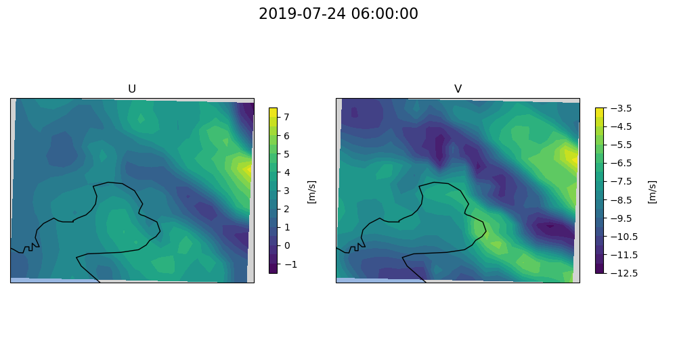
U
V
Populating A matrix

Figure 2: Wind velocity components (u and v) on 24 July 2019 at 06:00 UTC, along with a simplified representation of the population of the transfer matrix A.

Dispertion of Total Concentrations
In our framework, concentrations predicted by the dispersion model are denoted by $C$, while imported concentrations from external forecasts are denoted by $C$. The symbol $C$ is also used to represent concentrations that have been subsequently scaled or adjusted on the basis of the imported values following prediction. The pollutant concentrations at the forecast time step are then computed as:
$${A∙C}^{t+1}=C^{t}$$ | (5)
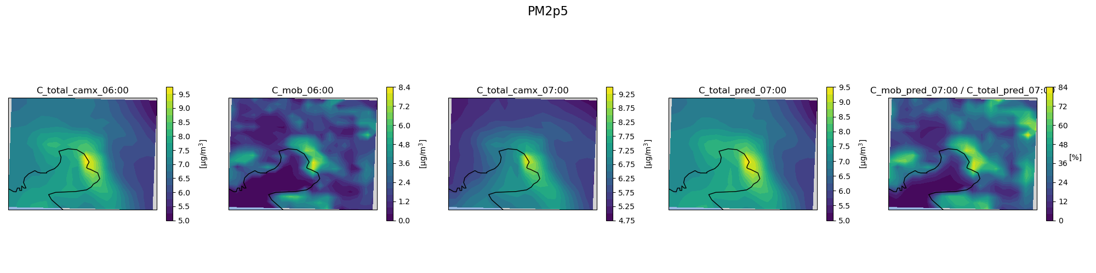
Figure 3: Prediction of total pollutant concentrations at the forecast hour (07:00 UTC - 24 July 2019), obtained from the dispersion of total pollutant concentrations at the current hour (06:00 UTC - 24 July 2019).
Dispersion

Dispertion of Traffic-Attributed Concentrations
This procedure is applied iteratively to estimate concentrations specifically attributable to traffic emissions. Traffic-related concentrations are calculated by scaling the improved concentrations of the current hour by the ratio of traffic emissions to total emissions:
$$C_{mob}^{t}=C^{t}\frac{{S^{t}}_{mob}}{S^{t} } \& A∙C_{mob}^{t+1}=C_{mob}^{t}$$
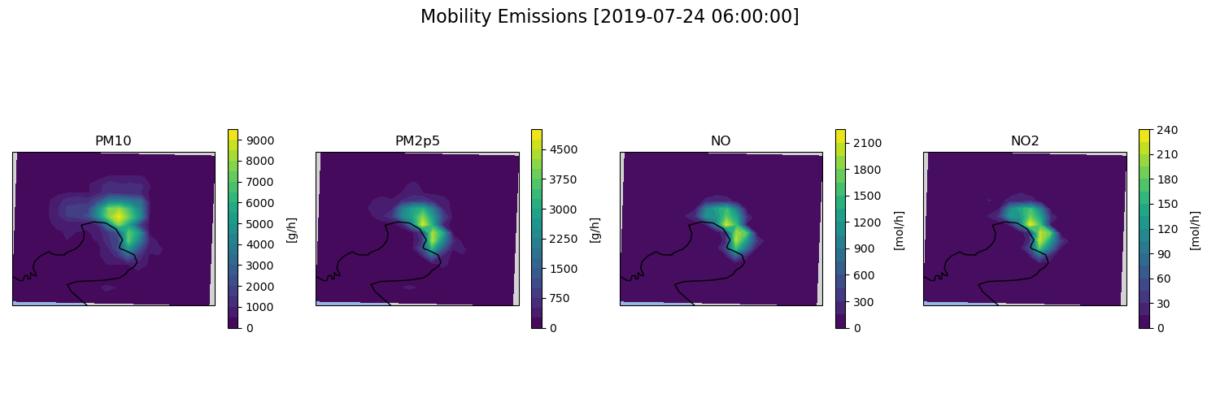
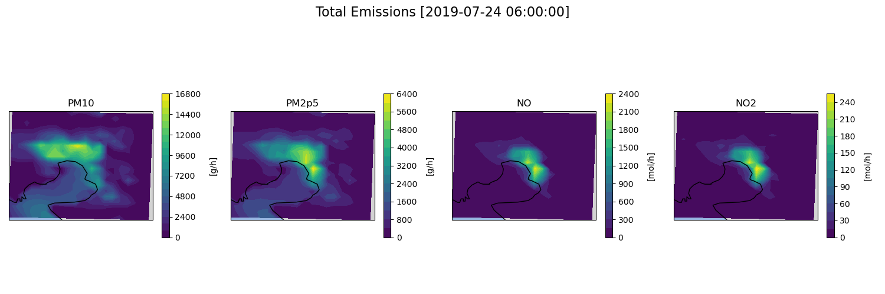
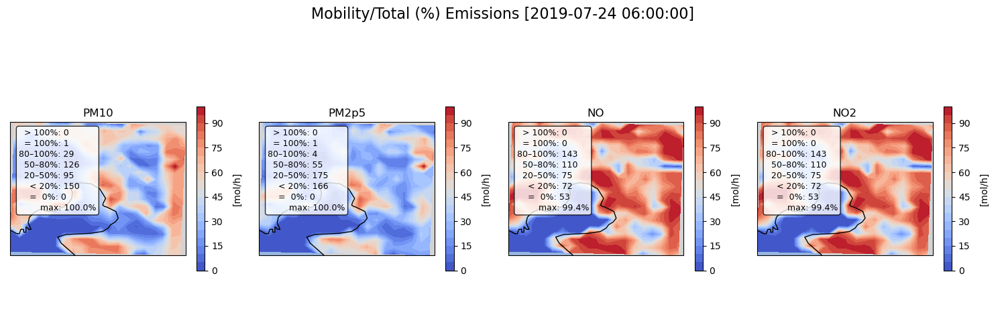
S_mob_6:00
S_6:00
S_rate_6:00
=

Figure 4: Calculation of the emission rate as the ratio of traffic emissions to total emissions for the current hour (06:00 UTC - 24 July 2019)
S_rate_6:00
=
*

Figure 5: Calculation traffic-attributed pollutant concentrations at the current hour (06:00 UTC - 24 July 2019)
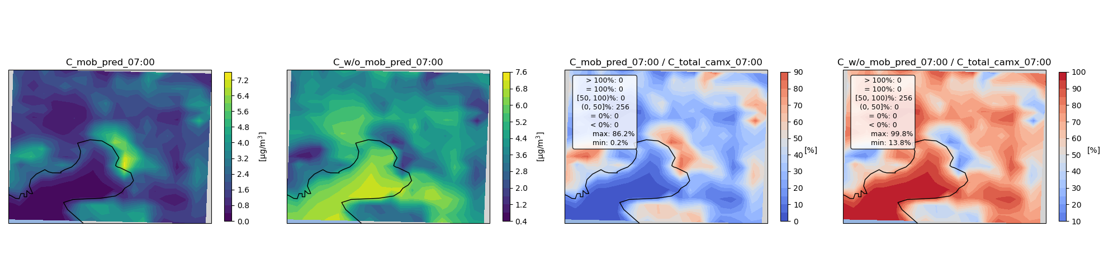
Dispersion

Figure 6: Prediction of traffic-attributed pollutant concentrations at the forecast hour (07:00 UTC - 24 July 2019), obtained from the dispersion of traffic-attributed pollutant concentrations at the current hour (06:00 UTC - 24 July 2019).

Predicted background concentrations, representing the pollution levels in the absence of traffic emissions, are obtained by subtracting the predicted traffic-attributed component from the total:
$$C_{{no}_{-}mob}^{t}=C^{t}-C_{mob}^{t}$$
=
-

Figure 7: Calculation of predicted background concentrations for the forecast hour (07:00 UTC, 24 July 2019), obtained by subtracting the predicted traffic-attributed component from the total pollutant concentrations.

Final Traffic-Attributed and Background Concentrations
To further refine the forecast, traffic-attributed concentrations are scaled by the ratio of predicted dispersed traffic-related concentrations to predicted total dispersed concentrations for the forecast hour:

$$C_{mob}^{t+1}=C^{t+1}∙\frac{C_{mob}^{t+1}}{C^{t+1}}$$
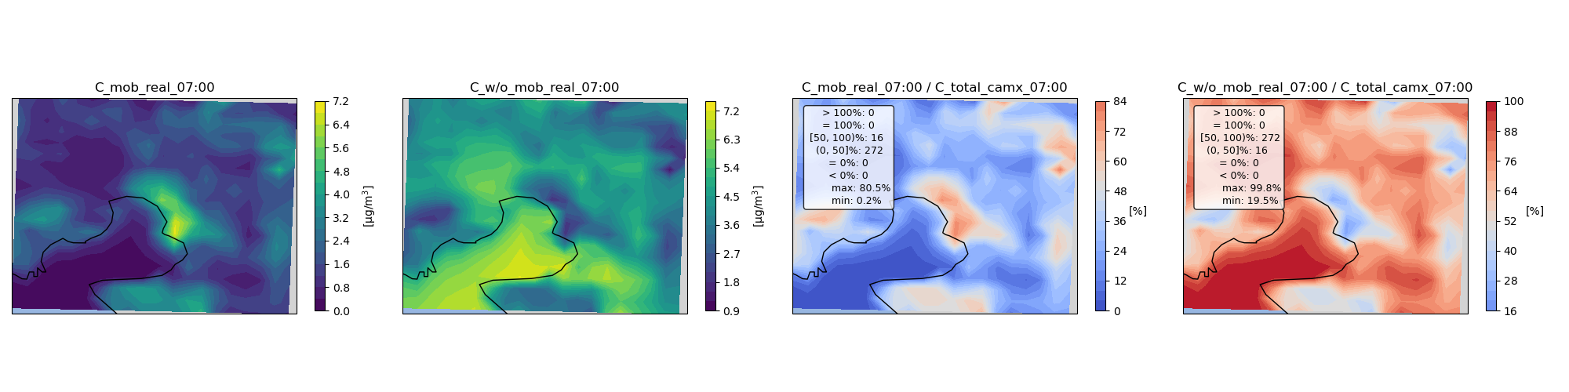
=
*

Figure 7: Calculation of traffic-attributed concentrations for the forecast hour (07:00 UTC, 24 July 2019), obtained by scaling the total predicted pollutant concentrations according to the ratio of predicted traffic-attributed concentrations to predicted total concentrations.

The corresponding background concentrations are then:
$$C_{{no}_{-}mob}^{t+1}=C^{t+1}-C_{mob}^{t+1}$$
=
-

Figure 8: Calculation of final background concentrations for the forecast hour (07:00 UTC, 24 July 2019), obtained by subtracting the scaled traffic-attributed component from the total pollutant concentrations.

European Air Quality Index (EAQI)
Pollutant concentrations are the standard outputs of air quality models, but on their own they are not easily interpretable by the non-scientific community. Without a clear reference framework, such values do not directly communicate potential health risks or the severity of air pollution episodes. To address this gap, the European Air Quality Index (EAQI) was applied to the corrected forecasts.
The EAQI is a standardized system developed by the European Environment Agency (EEA) to classify air quality into six categories: Good, Fair, Moderate, Poor, Very Poor, and Extremely Poor. These categories are based on concentration thresholds for pollutants such as ${PM}_{10}$, ${PM}_{2.5}$, and ${NO}_{2}$, and are linked to health-related guidance for both the general population and sensitive groups. The EAQI was applied to ${PM}_{10}$, ${PM}_{2.5}$, and ${NO}_{2}$, which are the pollutants most relevant to urban air quality conditions in Thessaloniki. For particulate matter, the classification is based on the 24-hour mean concentration, while for nitrogen dioxide it is based on the hourly concentration. This ensures consistency with the official methodology of the index. Furthermore, the EAQI was calculated separately for the AI-corrected forecasts, the traffic-related contributions, and the non-traffic-related contributions. This distinction provides valuable insight into both the overall state of air quality and the specific role of traffic emissions, supporting both scientific analysis and practical decision-making.
In summary, integrating the EAQI into the MOBILAIR system strengthens the interpretability of the results. It transforms technical outputs into clear, categorical information that can be readily understood by citizens, stakeholders, and policymakers, thereby enhancing the practical impact of the forecasting system.

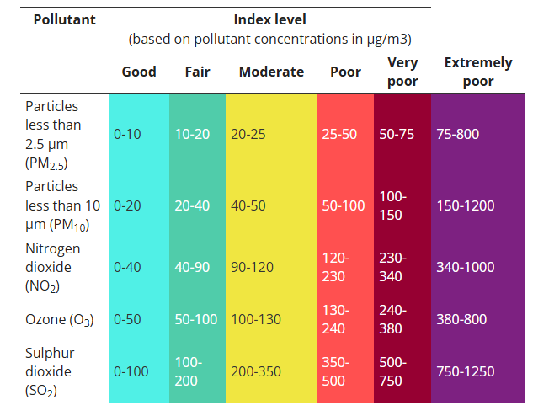
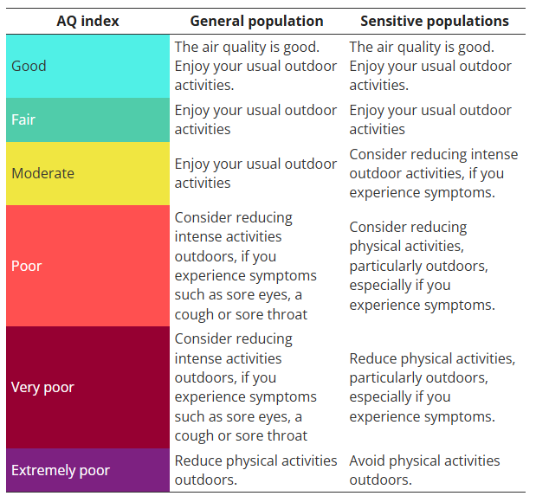

Figure 9: EAQI thresholds and associated health guidance, as defined by the European Environmental Agency (EEA)

Ethics and Data Protection
This deliverable relies exclusively on aggregated, anonymized, and non-personal data obtained from official emission inventories, publicly available databases, and traffic monitoring systems. No personal, sensitive, or identifiable information was collected or processed. All data handling procedures comply with applicable ethical standards and data protection regulations, including the EU General Data Protection Regulation (GDPR).

References
Alkabbani, H., Ramadan, A., Zhu, Q., & Elkamel, A. (2022). An Improved Air Quality Index Machine Learning-Based Forecasting with Multivariate Data Imputation Approach. Atmosphere, 13(7), 1144. https://doi.org/10.3390/atmos13071144
Sepp Hochreiter, Jürgen Schmidhuber; Long Short-Term Memory. Neural Comput 1997; 9 (8): 1735–1780. doi: https://doi.org/10.1162/neco.1997.9.8.1735
LeCun, Y., Bottou, L., Bengio, Y., & Haffner, P. (1998). Gradient-based learning applied to document recognition. Proceedings of the IEEE, 86(11), 2278–2324.
Zhang, Q., Han, Y., Li, V. O. K., & Lam, J. C. K. (2022). Deep-AIR: A hybrid CNN-LSTM framework for fine-grained air pollution estimation and forecast in metropolitan cities. IEEE Access, 10, 55818–55841. https://doi.org/10.1109/ACCESS.2022.3174853
Wang, Q., Ma, Y., Zhao, K. et al. A Comprehensive Survey of Loss Functions in Machine Learning. Ann. Data. Sci. 9, 187–212 (2022). https://doi.org/10.1007/s40745-020-00253-5
Willmott, C. J. (1981). ON THE VALIDATION OF MODELS. Physical Geography, 2(2), 184–194. https://doi.org/10.1080/02723646.1981.10642213
European Environment Agency. European Air Quality Index. Retrieved February 11, 2026, from https://airindex.eea.europa.eu/AQI/index.html
Delis, Argiris. An Implicit Numerical Scheme for the Atmospheric Pollution. 2008.

