D2.1: Mobile application including digital campaigns for AQ and UM issues, awareness alerts, route guidance and assessment of potential UM measures in at least TRL 7


Other Information
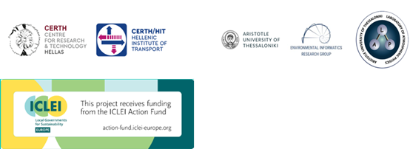

Phase 2. Infrastructure & Data Setup and Preparation Activities

D2.1 Mobile application including digital campaigns for AQ and UM issues, awareness alerts, route guidance and assessment of potential UM measures in at least TRL 7

Contributing Authors
Vasileios Mizaras | Hellenic Institute of Transport/ CERTH
Panagiotis Tzenos | Hellenic Institute of Transport/ CERTH
Athanasios Tolikas | Hellenic Institute of Transport/ CERTH
Alexandros Deligiannis | Hellenic Institute of Transport/ CERTH
Zisis Maleas | Hellenic Institute of Transport/ CERTH
Sofia Alvanou | Hellenic Institute of Transport/ CERTH

Table of Contents
1. Data Sources’ Readiness (R2.2) 6
1.1 Environmental and Air Quality Data 6
1.2 Downscaling of Air Quality Estimates 7
1.3 Mobility and Transport Data 8
1.4 Behavioural and User Interaction Data 8
1.5 Data Transmission and Integration 9
1.6 Overall Data Readiness 9
2. Digitalisation of Urban mobility measures 12
2.1 Introduction of Mobilair’s Vision for Effective Urban Mobility Management Based on Citizens’ Engagement 12
2.2 Air Quality & Mobility Assets Display and Incentives 13
Air quality display 13
Mobility assets display 14
2.3 Gamification, Quiz & Survey 15
2.3.1 Overview and Design Rationale 15
2.3.2 Gamification system 15
2.3.3 Quiz module 18
2.3.4 Survey module 19
2.3.5 Integration within the Mobilair App and behavioural impact 20
2.4 Eco-Routing 20
3. AI Algorithms 29
3.1 Objective and solution architecture 29
3.2 Methodological Approach of AI nudging recommendation engine 32
4. Mobile Application (R2.5.2) 36
4.1 Application Overview 36
4.2 Application Features & Screenshots 37
User authentication 37
On-boarding survey 37
Air Quality 37
Eco-routing 37
Level progress, eco-coins and gifts 37
Gift redemption 37
Quizzes and Surveys 38
References 39

List of Tables
Table 1: Overview of Data Sources Integrated in the MOBILAIR Platform 10
Table 2 Full set of level- titles 16
Table 3 Summary of 10 survey modules and their respective engagement objectives 19
Table 4: example trip plan XXX 33

List of Figures
Figure 1 How the Digital Facilitators may transform user Mobility behaviour, Urban Mobility measures and social engineering 12
Figure 2 Weather and Air Quality real time data 14
Figure 3 Public Transport routing visualisation 15
Figure 4 Figure of alternative solution types 21
Figure 5: Multimodal Trip Planner internal testbed 26
Figure 6 30
Figure 7 From left to right: (i) Example of on-boarding survey question, (ii) Air quality screen, (iii) Eco routing example, (iv) Level and points screen, (v) Quiz and surveys screen, (vi) Quiz example, (vii) Survey example, (viii) What-if question example (nudging) 38

1. Data Sources’ Readiness (R2.2)
The MOBILAIR platform relies on a diverse set of environmental, mobility and behavioural datasets that enable the integration of air quality modelling, mobility analytics and user interaction services. The readiness of these data sources has been evaluated with respect to their availability, accessibility, update frequency and compatibility with the MOBILAIR data management infrastructure.
The project builds upon existing monitoring infrastructures, environmental modelling systems and mobility data resources available in Thessaloniki, while also incorporating additional datasets generated during the implementation of the project. These data streams are integrated into a unified analytical environment that supports the development of artificial intelligence services and behavioural nudging mechanisms aimed at encouraging more sustainable travel choices.
The overall data readiness strategy focuses on three main domains:
- Environmental and air quality data, supporting pollution monitoring and forecasting
- Mobility and transport data, enabling multimodal routing and exposure analysis
- User interaction and behavioural data, supporting personalised recommendations and behavioural evaluation
The following subsections describe the main datasets currently integrated within the MOBILAIR platform.

1.1 Environmental and Air Quality Data
Environmental data constitute a central component of the MOBILAIR analytical framework. Air quality forecasts are produced through a modelling chain developed by the Laboratory of Atmospheric Physics at the Aristotle University of Thessaloniki. The modelling framework integrates several established atmospheric modelling tools, including:
- the Weather Research and Forecasting (WRF) model for meteorological simulation,
- the NEMO model for natural emission estimation, and
- the CAMx atmospheric chemistry and transport model for pollutant dispersion and transformation.
The modelling system produces hourly forecasts of pollutant concentrations for the metropolitan area of Thessaloniki. The outputs are delivered as geospatial raster datasets (GeoTIFF format) with a spatial resolution of approximately 2 km², which serve as the primary environmental input for the MOBILAIR platform.
The modelling outputs include key traffic-related pollutants such as particulate matter and nitrogen dioxide (e.g., PM10, PM2.5 and NO₂) that are strongly associated with urban mobility patterns and transport emissions. These indicators provide the basis for estimating environmental conditions and evaluating potential exposure associated with urban travel behaviour.
In addition to model forecasts, ground-based air quality observations are used to support calibration and validation procedures. These measurements are retrieved on an hourly basis through the CairCloud API, in collaboration with the Municipality of Thessaloniki. The monitoring infrastructure includes both existing monitoring stations and additional sensors deployed within the framework of the MOBILAIR project.
The observational datasets undergo a preprocessing workflow that includes:
- quality control checks to detect unrealistic or inconsistent measurements,
- filtering of monitoring stations with incomplete historical records, and
- imputation of missing values using machine-learning techniques.
The resulting dataset provides a harmonized environmental database that supports both the operational forecasting system and the development of the platform’s analytical modules.

1.2 Downscaling of Air Quality Estimates
The regional air quality forecasts generated by the WRF–NEMO–CAMx modelling chain provide pollutant concentration fields at a spatial resolution of approximately 2 km². While this resolution is appropriate for regional analysis, urban mobility applications require more detailed spatial information to estimate exposure along specific travel routes and within dense urban corridors.
To address this limitation, MOBILAIR incorporates a downscaling procedure that refines regional pollutant forecasts using urban mobility context data. This procedure combines the model outputs with detailed road network information and traffic-related indicators to redistribute pollutant concentrations at a finer spatial scale.
The downscaling process includes the following steps:
- extraction of the urban road network using geographic information systems and OpenStreetMap data,
- classification of road segments according to traffic characteristics and mobility patterns,
- definition of weighting factors based on road attributes such as road category, lane length and mobility activity, and
- redistribution of pollutant concentrations across the road network based on these weights.
The resulting outputs consist of refined air quality maps and exposure indicators at street-network level, enabling the integration of environmental information into the routing services and behavioural recommendation mechanisms of the MOBILAIR platform.

1.3 Mobility and Transport Data
Mobility datasets provide the spatial and operational context required for route planning, mobility analytics and exposure-aware travel recommendations.
The core representation of the urban transport network is derived from OpenStreetMap (OSM) data. These datasets are processed using the OSMnx Python library, which converts raw map data into a routable graph representation consisting of nodes and edges representing intersections and road segments. This graph structure forms the basis for shortest-path computations and multimodal routing services implemented in the MOBILAIR platform.
Additional mobility-related information is provided through the Thessaloniki Smart Mobility Living Lab (ThSMLL) operated by the Hellenic Institute of Transport (CERTH/HIT). The Living Lab provides access to urban mobility datasets and experimentation infrastructure supporting the development and validation of smart mobility services within the city.
The datasets available through the ThSMLL include information related to:
- traffic activity patterns across the urban road network
- public transport infrastructure and operational characteristics
- shared micromobility services such as e-bike and e-scooter systems
These datasets enable the integration of multiple transport modes within the multimodal trip planner and support the estimation of environmental impacts associated with alternative travel choices.

1.4 Behavioural and User Interaction Data
The MOBILAIR mobile application generates behavioural datasets that support the development of personalised mobility recommendations and the evaluation of user engagement with the platform’s services.
User-related information originates from several components of the mobile application, including:
- the initial user profile questionnaire, which captures information related to mobility habits and user preferences
- the route planning interface, which records trip planning requests and selected itineraries
- interactive application components, such as gamification features, quizzes and surveys designed to promote behavioural awareness
These datasets enable the analysis of user responses to behavioural nudging strategies and provide the basis for the adaptive recommendation mechanisms implemented in the MOBILAIR AI module. All user-generated information is handled in accordance with data protection regulations, ensuring that personal data are processed in anonymized or aggregated form whenever possible.

1.5 Data Transmission and Integration
Data flows within the MOBILAIR system are managed through secure data exchange mechanisms. Environmental model outputs and derived datasets are transmitted via Secure File Transfer Protocol (SFTP) connections, ensuring reliable and protected transfer of geospatial files between modelling components and the central platform infrastructure.
The system maintains continuously updated datasets that include:
- hourly pollutant concentration forecasts,
- derived air quality indicators, and
- estimates of traffic-related emission contributions.
These datasets are subsequently integrated with mobility and behavioural data streams to support the platform’s analytical services, exposure estimation modules and decision-support functionalities.

1.6 Overall Data Readiness
At the current stage of the project, most of the required datasets are already operational and accessible through existing infrastructures and institutional collaborations. Environmental modelling outputs, monitoring station observations, road network data and mobility datasets from the Thessaloniki Smart Mobility Living Lab have been successfully integrated into the MOBILAIR analytical environment.
As the project progresses, additional datasets generated through the mobile application and pilot activities will further enrich the system’s knowledge base. This level of readiness ensures that the MOBILAIR platform can support the implementation and evaluation of its core functionalities, including exposure-aware routing, behavioural nudging mechanisms and data-driven decision-support services for sustainable urban mobility.
To provide a consolidated overview of the datasets currently integrated within the MOBILAIR platform, Table 1 summarises the main data sources, their providers, update frequency and their role within the system’s analytical framework.

Table 1: Overview of Data Sources Integrated in the MOBILAIR Platform
Data Category | Main Source / Provider | Data Type & Format | Update Frequency | Role in MOBILAIR
Air Quality Forecasts | AUTH – Laboratory of Atmospheric Physics (WRF–NEMO–CAMx modelling chain) | Raster datasets (GeoTIFF) | Hourly | Provides pollutant concentration forecasts used for environmental assessment and exposure modelling
Air Quality Observations | Monitoring stations and project sensors via CairCloud API (Municipality of Thessaloniki) | Time-series measurements (CSV / API retrieval) | Hourly | Used for model calibration, validation, and AI-based forecast correction
Meteorological Data | WRF meteorological model outputs | Gridded meteorological variables | Hourly | Supports atmospheric dispersion modelling
Road Network Data | OpenStreetMap processed via OSMnx | Graph representation (nodes and edges) | Periodic updates | Provides the spatial network structure used for routing
Urban Mobility Data | Thessaloniki Smart Mobility Living Lab (CERTH/HIT) | Traffic indicators, mobility infrastructure data, public transport context, micromobility infrastructure | Periodic updates | Provides urban mobility datasets used for multimodal routing, traffic context analysis and pollutant downscaling
User Behaviour Data | MOBILAIR mobile application | Anonymised interaction records | Continuous | Supports personalised mobility recommendations and behavioural analytics
Engagement Data | Gamification modules, surveys, and quizzes | User interaction datasets | Continuous | Supports evaluation of behavioural nudging strategies
Environmental Indicators | Derived from modelling and observation datasets | Processed environmental indicators | Hourly | Provides simplified air quality information for applications and dashboards

2. Digitalisation of Urban mobility measures

2.1 Introduction of Mobilair’s Vision for Effective Urban Mobility Management Based on Citizens’ Engagement
Figure 1 How the Digital Facilitators may transform user Mobility behaviour, Urban Mobility measures and social engineering

Mobilair project adopts a holistic approach in improving Urban environment in terms of Air Quality and Sustainable Mobility, which has as main axis the introduction and use of digital facilitators.
The digital facilitators could be a set of digital assets, such as public Totem digital displays, mobile applications and datasets, which are used as the tools to attract and engage the Citizens. Mobilair’s vision considers Citizens are the key contributors to the air quality and mobility problems of everyday life, and as a result they are also the solution to a radical shift in quality of urban life. This shift may happen only if the same people who do a travel choice with a high negative impact on the society, in terms of air quality, noise, congestion etc, change their behavious towards more eco-conscious travel choices through modal shift from car to active transport and public transport.
Mobilair envisages 5 escalating steps that complement each other (figure 1):
- Information: a simple set of information for Air Quality level and sustainable mobility makes the user aware of the current situation
- Nudging the user: the digital facilitators provide the information in such a way that nudges the user towards desired behaviour
- Educate the user: the digital facilitators provide insights regarding the urban life operations that assist the user in fully grasping the problem and what it causes it.
- Engage the user: gamification and incentives trigger the users’ engagement in frequent use and adoption of the digital facilitators
- What if gamification: the mobile application intends to comprehend user actions by analysing user behaviour in future or hypothetical scenarios

2.2 Air Quality & Mobility Assets Display and Incentives

Air quality display
The air quality display provides a qualitative value to the users about the current state of pollution in the area. The possible values are:
- Very good
- Good
- Moderate
- Bad
- Very bad
As seen in figure X, the value is displayed in a color-coded gradient bar for easy understanding, with green and red being the “very good” and “very bad” values accordingly. The language used in this display is kept simple, and words such as “hazardous” are purposefully avoided as not creating unnecessary panic. Lastly, the current time and weather forecast are included in the display for stylistic and informative purposes.
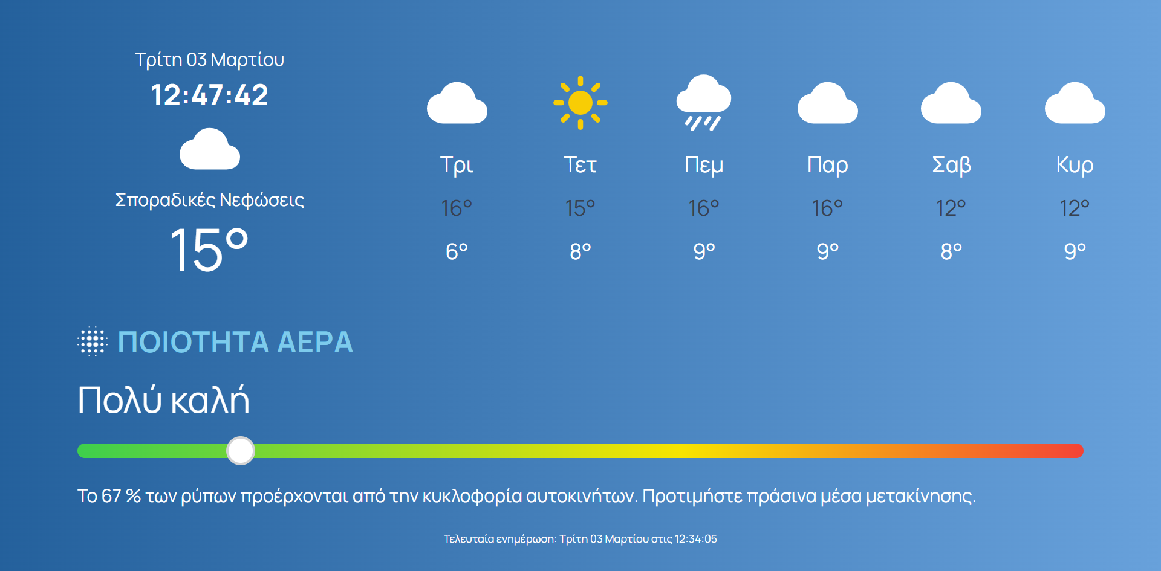
Figure 2 Weather and Air Quality real time data

Mobility assets display
The mobility assets display provides directions and bus stop information for key destinations in the city of Thessaloniki. Currently, the available destinations are:
- Airport
- Suburban Bus Station Makedonia
- Suburban Bus Station Chalkidikis
- Aristotle Square
The destinations are cycled through every 15 seconds and for each destination the following information is provided:
- Name of bus stop
- Walking time to bus stop
- Bus line
- Arrival of bus at the stop
- Walking direction from the display to the bus stop
Additionally, the viewer can scan the correspondent QR code to load the information on the display directly into their phones and continue their journey. This feature enables the viewers to have continuous access to key information and assist them to reach their desired destination.
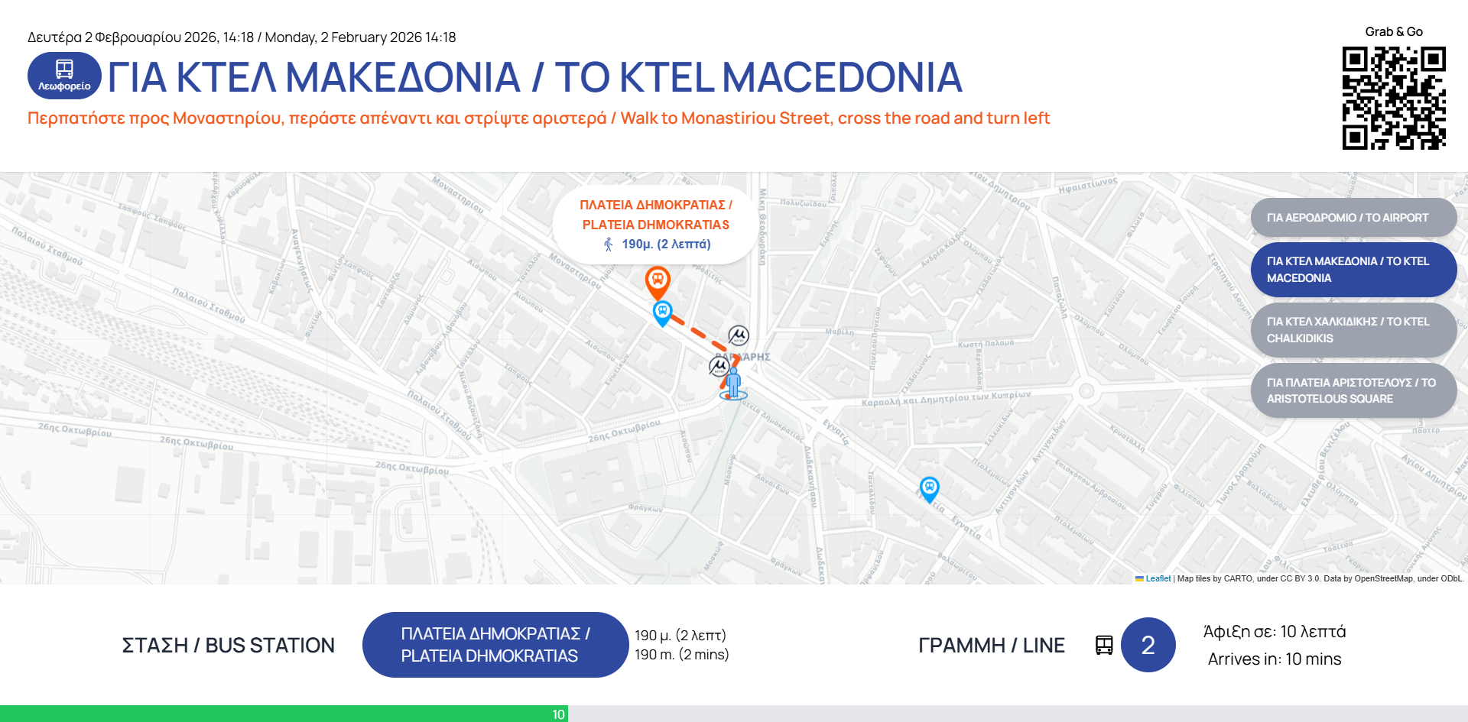
Figure 3 Public Transport routing visualisation

2.3 Gamification, Quiz & Survey

2.3.1 Overview and Design Rationale
The Mobilair mobile application integrates a gamification framework alongside structured quiz and survey modules to promote sustained user engagement and support behavioural change toward sustainable urban mobility. These three components, gamification, quiz, and survey, are designed as an interconnected system that rewards users for active participation, increases awareness of environmental and mobility-related issues, and generates valuable data on citizen preferences and attitudes.
The design rationale draws on established principles of behavioural science and digital engagement, including reward-based motivation, progressive challenge, feedback loops, and personalised goal setting. By converting knowledge acquisition and opinion sharing into rewarding experiences, the application encourages users to engage repeatedly, develop eco-conscious habits, and contribute meaningfully to the project's data collection objectives.

2.3.2 Gamification system

Points and levelling system (XP)
The core gamification methodology is a points-based progression system built around Experience Points (XP). Each user begins at Level 1 and advances to the next level upon accumulating 100 XP. The system is designed to be inclusive — even users who answer quiz questions incorrectly receive participation points — while still rewarding accuracy and effort.
XP can be earned through multiple channels within the application, ensuring that users with different engagement patterns and preferences can still progress. The table below summarises all available XP-earning activities:

Activity | XP Awarded | Notes
Quiz – Correct Answer (Level 1) | 40 XP | Per question
Quiz – Correct Answer (Level 2) | 80 XP | Per question
Quiz – Correct Answer (Level 3) | 120 XP | Per question
Quiz – Participation (any level) | 20–60 XP | Even for wrong answers
Survey completion | 50 XP | Per survey module
Bonus question (survey) | +10 XP | Optional follow-up
User registration (sign-up) | 20 XP | One-time reward
Daily app engagement | 10 XP | Definition TBD
"What Would You Do?" response | 20 XP | Per response

The range of XP earnings from quiz activities alone (600–1,200 XP across 15 questions) allows for approximately 6 to 12 level advancements, providing a meaningful progression arc for users who engage thoroughly with the quiz content.

Eco- Coins and reward mechanism
Alongside XP, the application introduces a virtual currency called Eco-Coins, which functions as the reward medium within the gamification ecosystem. Eco-Coins are awarded each time a user advances to a new level, according to the formula:

Eco-Coins earned per level-up = 5 + (current player level)

This progressive formula ensures that long-term users receive increasing rewards as they advance, incentivising continued engagement. Accumulated Eco-Coins can be redeemed in exchange for prizes or benefits, the catalogue of which is managed separately by the application administrators.

Level titles
To further personalise the experience and provide symbolic recognition of progress, each level is associated with a thematic title available in both English and Greek. These titles reflect the application's sustainability mission, evolving from introductory environmental awareness at lower levels to leadership and advocacy roles at higher levels. The full set of level titles is presented in the table below:
Table 2 Full set of level- titles
Level | English Title | Greek Title
1 | Curious Commuter | Περίεργος Μετακινούμενος
2 | Green Starter | Πράσινος Αρχάριος
3 | Eco Explorer | Οικο-Εξερευνητής
4 | Mindful Mover | Συνειδητός Μετακινούμενος
5 | Carbon Cutter | Μειωτής Άνθρακα
6 | Urban Cyclist | Αστικός Ποδηλάτης
7 | Public Transit Pro | Ειδικός στις Δημόσιες Συγκοινωνίες
8 | Clean Air Advocate | Υποστηρικτής Καθαρού Αέρα
9 | Low-Impact Living | Ζωή Χαμηλού Αποτυπώματος
10 | Sustainability Ally | Σύμμαχος Βιωσιμότητας
11 | City Greenkeeper | Φύλακας Πρασίνου Πόλης
12 | Eco Habit Builder | Δημιουργός Οικολογικών Συνηθειών
13 | Climate-Smart Citizen | Κλιματικά Συνειδητός Πολίτης
14 | Urban Nature Guardian | Προστάτης Αστικής Φύσης
15 | Sustainable Living Champion | Πρωταθλητής Βιώσιμης Ζωής
16 | Climate Action Leader | Ηγέτης Κλιματικής Δράσης
17 | Green City Influencer | Πρεσβευτής Πράσινης Πόλης
18 | Net-Zero Navigator | Οδηγός Μηδενικού Αποτυπώματος
19 | Urban Sustainability Master | Δάσκαλος Αστικής Βιωσιμότητας
20 | Future City Architect | Αρχιτέκτονας της Πόλης του Μέλλοντος

These titles serve a dual function: they provide users with a sense of identity and achievement, and they reinforce the application's broader messaging around sustainable mobility and environmental responsibility.

"What Would You Do?" Interactive Feature
In addition to the quiz and survey modules, the gamification system includes a dedicated interactive feature titled "What Would You Do?". This feature presents users with scenario-based questions related to urban mobility choices and environmental behaviour, rewarding each response with 20 XP. This feature broadens the range of engagement mechanisms, offering a narrative or deliberative format that complements the factual nature of the quiz and the structured format of the surveys.

2.3.3 Quiz module

Purpose and Objectives
The quiz module serves as an educational and engagement tool designed to raise user awareness on topics directly related to the MOBILAIR project's thematic scope: air quality, urban mobility, sustainable transport modes, and the environmental impact of individual travel choices. Questions are presented through an interactive interface within the mobile application and are integrated with the gamification system to reward both participation and correct responses.

Question Structure and Typology
The quiz consists of 15 questions in total, distributed across three difficulty levels (Level 1, Level 2, Level 3), with five questions per level. Questions are presented in multiple-choice format, with either four options (for knowledge-based questions) or binary True/False format (for verification-type questions). Each question is accompanied by a brief explanatory note that is displayed following the user's response, reinforcing the educational objective of the module.
The thematic content of the quiz covers the following subject areas:
- Greenhouse gas emissions by transport mode
- Air pollutants associated with road traffic (e.g. NO₂, PM2.5)
- Active mobility modes and their environmental benefits
- Car-sharing and its impact on vehicle numbers
- Lifecycle emissions of electric vehicles
- Cycling performance and urban cycling coverage
- Definition and scope of micromobility
- Carbon sequestration and vehicle CO₂ output
- Share of transport in urban CO₂ emissions
- In-vehicle air quality relative to outdoor environment
- Time losses due to traffic congestion in European cities
- Comparative environmental footprint of e-scooters versus buses

Scoring and point allocation
The scoring system distinguishes between correct and participation-only responses, as follows:
Difficulty Level | Points (Correct Answer) | Points (Participation)
Level 1 | 40 XP | 20 XP
Level 2 | 80 XP | 40 XP
Level 3 | 120 XP | 60 XP

This structure ensures that users are incentivised to engage with all questions regardless of their level of prior knowledge, while still rewarding accuracy. The total XP achievable from quiz completion ranges from 600 XP (all participation points, no correct answers) to 1,200 XP (all correct answers at full value), corresponding to between 6 and 12 player level advancements.

2.3.4 Survey module

Purpose and objectives
The survey module is designed to collect structured data on user attitudes, behaviours, and preferences related to urban mobility and air quality. Unlike the quiz, which measures knowledge, the surveys capture self-reported information that feeds directly into the project's understanding of citizen needs, barriers to sustainable transport adoption, and willingness to change travel behaviour. Survey responses also contribute to the personalisation of the application's features, such as route recommendations and nudging content.

Survey design and branching logic
The survey module comprises 10 thematic survey modules, each built around a branching question structure. Each module begins with a primary question, the response to which determines the follow-up question presented to the user. This branching design (also referred to as conditional logic) ensures that questions remain relevant to the individual user's context, reducing survey fatigue and improving response quality. Selected survey modules include an optional bonus question that rewards an additional 10 XP upon completion.
The 10 survey modules and their respective engagement objectives are summarised in the table below:
Table 3 Summary of 10 survey modules and their respective engagement objectives
No. | Survey Topic | Engagement Objective
1 | Cycling Mobility | Assess willingness to cycle and infrastructure needs
2 | Public Transport Usage | Understand barriers and motivations for PT adoption
3 | Electric Mobility | Gauge interest in EV/e-bike/e-scooter adoption
4 | Air Quality & Health | Measure environmental awareness in travel decisions
5 | Micromobility | Explore shared e-scooter and bike usage patterns
6 | Parking & Car Ownership Costs | Raise awareness of real costs of private car use
7 | Telework & Reduced Commuting | Examine remote work's impact on mobility
8 | Awareness of Transport Alternatives | Identify information gaps for modal shift
9 | Willingness to Pay for Green Transport | Understand environmental value preference
10 | Multimodal Transport | Explore MaaS acceptance and multimodal habits

Scoring and point allocation
Survey participation is rewarded as follows:
Action | Points Awarded
Survey completion (per survey pair) | 50 XP
Bonus question response | +10 XP

Points are awarded upon completion of each survey module, irrespective of the specific answers provided, ensuring that data collection is not influenced by incentive-driven response bias. The bonus question, where present, offers additional XP for users who choose to provide further detail.

2.3.5 Integration within the Mobilair App and behavioural impact
The gamification, quiz, and survey components are deeply integrated within the broader Mobilair application ecosystem. The XP and Eco-Coin systems connect across all engagement features, ensuring that users who interact with any aspect of the application, whether completing surveys, answering quiz questions, engaging with the eco-routing planner, or simply opening the application daily, are recognised and rewarded for their participation.
From a behavioural standpoint, this integrated design supports several key mechanisms identified in the nudging and engagement literature. The level progression system provides users with continuous feedback on their engagement and sets implicit targets that encourage sustained participation. The quiz, with its explanatory follow-up content, aims to shift users from extrinsically motivated participation — earning points, toward intrinsically motivated engagement rooted in learning and environmental awareness. Survey responses, in turn, directly inform the personalised generalised cost score used in the multimodal trip planner (described in Section 2.4), enabling the application to tailor route recommendations to individual modal preferences. Finally, the level title system assigns users symbolic identities, such as 'Eco Explorer' or 'Climate Action Leader', that reinforce the project's sustainability values and foster a sense of shared purpose among participants.
Together, these features position the Mobilair application not merely as a trip-planning utility but as a comprehensive digital facilitator of sustainable mobility behaviour, aligned with the project's overarching objectives of reducing urban air pollution and promoting environmentally responsible travel choices.

2.4 Eco-Routing
Mobilair has integrated an in-house developed multimodal trip planner that leverages the open source project OpenTripPlanner (OTP) as a robust aggregation service. This solution supports seamless urban mobility across pedestrian (w), own car (oc), shared eBike (b), shared scooter (s), public transport (pt), and own bike (ob) modes, empowering efficient door-to-door journeys.
The service optimally combines multiple modes of transport and produces viable connecting routes for the user’s preferred origin – destination pairs. For solving the multimodal trip planning problem, the various alternative unimodal and multimodal solutions that can be considered reasonable from users’ perspective in the city of Thessaloniki, Greece were identified. Considering the spatial allocation of the shared mobility hubs and the bike-sharing stations, the following alternative solution types emerged:
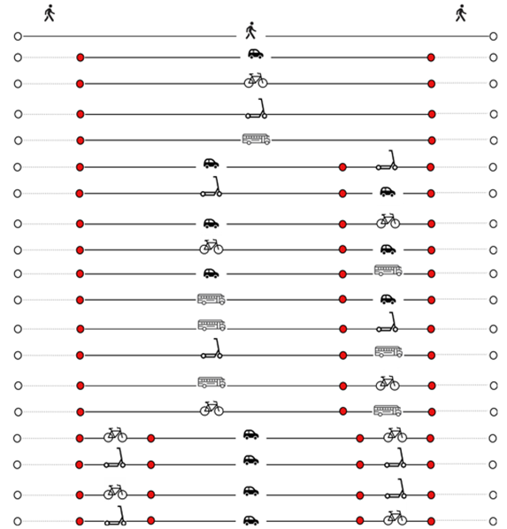
Figure 4 Figure of alternative solution types
Overall logic
The trip planner utilizes two separate and individual cost calculation functions:
- A comprehensive total cost function that considers all actual and perceived financial and external costs. This calculation supports two key objectives:
  - Clearly explain to the user in numerical terms a) the actual total cost, “out of his pocket money” (for example, cost of car use per km including maintenance not only gas costs), as well as b) byproduct costs imposed to him/her (i.e. time to look for parking), and most importantly the c) social cost of his/her mode choice in monetarized value.
  - Objectively, prioritize the alternative trip solutions. The prioritization could be done in terms of total cost or external cost or user-only costs, depending on the situation.
- A customizable and personalised generalized cost score. A separate primary and simplified metric, which is used to match diverse individual user preferences. This is used independently from the total cost function to sort and rank routes based on previous user modal preferences.
Both are used by the AI, nudging, module to suit actual user preferences (deriving from the customizable and personalised generalized cost score), while pushing for socially acceptable routes (deriving from the comprehensive total cost function).
Core architecture overview
The solution consists of two main components:
- External Route API: Public HTTPS endpoint with Basic Auth, handling client requests, validation, and result aggregation (aggregation service).
- Internal OTP Router: One deployed instance exposing the /plan routing API, configured with OSM and GTFS feeds.
The Route API component performs authentication and any multi-call orchestration, evaluates the estimated cost of the produced itineraries and then forwards sanitized routing responses back to clients.
Internal OTP calls and leg decomposition
The OTP Router endpoint accepts a single mode parameter and computes individual itineraries between origin and destination in one call. To support richer semantics (e.g., switching between own car and transit or chaining shared micromobility and walking), the aggregation service decomposes the user’s initial request into a sequence of legs:
- Each leg has: from, to, any specific constraint to be applied, and a specific OTP mode setting.
- Leg boundaries typically occur at:
  - Public transport access/egress points (stations/stops).
  - Shared vehicle pickup/dropoff zones.
Example user request: from=A, to=D by using transport modes= ["s", "pt", "w"]. The aggregation service can then compute:
- Leg 1 (walk): A → pick up station S, modes=WALK​
- Leg 2 (shared scouter): S → drop off station T, modes=SCOOTER
- Leg 3 (walk): T → stop Y, modes=WALK, TRANSIT.​
- Leg 4 (pedestrian): Y → D, modes=WALK.​
Each of the above legs is an independent HTTP call to OTP’s /plan. Similar calls are made for transit and walking legs, adjusting arrival/departure preferences and search windows.
Itinerary aggregation and timing
Once per-leg itineraries are retrieved, the service merges them into a single and consistent multimodal route. The departure time for each leg after the first is the arrival time of the previous leg plus a configurable transfer buffer. The service also ensures that the destination of leg N is within a defined tolerance of the origin of leg N+1 and adjusts via an extra micro-walking leg if necessary. Lastly, it converts OTP’s internal leg structures into a unified schema regardless of the underlying OTP mode identifiers.
If multiple combinations of intermediate points (e.g. several shared vehicle stations) are considered, the service plans each candidate path (subject to a cap) and then selects the best global itinerary according to configured optimization criteria.
Handling micromobility and own vehicles
For shared eBikes and scooters, the aggregation service selects candidate bike rental stations near origin and destination points defined in the user’s request, plans a walking leg from origin to pickup station, a shared ebike/scooter leg between stations and a walking leg to the final destination.
Own car (oc) and own bike (ob) segments are simpler: they are planned as singlemode- legs where the entire distance is driven or cycled.
Itinerary cost estimation calculations
The service evaluates the estimated cost of each produced itinerary, based on the following criteria:
Mode | Total (Direct/indirect) financial cost
Car | € 0,18 | per km ⁽¹⁾
Bus | € 0,60 | ticket based entire trip
Metro | € 0,60 | ticket based entire trip
shared micromobility (e-scooter, e-bike) | € 0,45 | Average per trip (unlock) ⁽²⁾
shared micromobility (e-scooter, e-bike) | € 0,20 | Average per minute ⁽²⁾
own bike | € -
Pedestrian | € -

(1)
- Ayvens Car Cost Index 2025
(https://www.ayvens.com/-/media/ayvens/public/shared/documents/ayvens-car-cost-index-2025---march-2025.pdf)
- EU fleet TCO analysis: FIA Region1 (2022) (https://www.fiaregion1.com/wp-content/uploads/2022/11/FIA_Study_CostofOwnership.pdf) Passenger cars in the EU - Statistics Explained - Eurostat
(2)
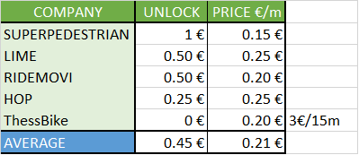

Mode | Time related costs per minute
Mode | Travel time in minutes | Cost of travel time €/min ⁽³⁾ | Waiting time at stop/station (Average) in min | Cost of waiting time €/min ⁽³⁾ | Seeking Parking time (Average) in min (4) | Cost of parking time (Average) €/min ⁽³⁾
Car | As calculated by routing | € 0,10 | 0 | € - | 4 | € 0,17
Bus | As calculated by routing | € 0,10 | 9 | € 0,08 | 0 | € -
Metro | As calculated by routing | € 0,10 | 2 | € 0,08 | 0 | € -
shared micromobility (e-scooter, e-bike) | As calculated by routing | € 0,10 | 0 | € - | 0 | € -
shared micromobility (e-scooter, e-bike) | As calculated by routing | € 0,10
own bike | As calculated by routing | € 0,10 | 0 | € - | 0 | € -
Pedestrian | As calculated by routing | € 0,15 | 0 | € - | 0 | € -

(3)
- Transportation Development Study for the Thessaloniki Metro
(4)
- Estimating Parking Search Times for Transport Modelling in Europe: A Hierarchical Bayes Approach with Cross-Regional Data Integration
- https://www.researchgate.net/publication/392778310_Estimating_Parking_Search_Times_for_Transport_Modelling_in_Europe_A_Hierarchical_Bayes_Approach_with_Cross-Regional_Data_Integration
 | Mode | Parking cost
 | Mode | Average on street cost per hour. Only for city centre, only for car mode | Average off street cost per hour. Only for city centre, only for car mode
 | Car | € 1,70 | € 4,00
 | Bus | € - | € -
 | Metro | € - | € -
 | shared micromobility (e-scooter, e-bike) | € - | € -
 | own bike | € - | € -
 | Pedestrian | € - | € -

Mode | External cost ⁽⁵⁾  per km | CO2 emissions ⁽⁶⁾  gr per km
Mode | External cost ⁽⁵⁾  per km | CO2 emissions ⁽⁶⁾  gr per km | Ckal consumed per km
Car | € 0,18 | 130 | 0
Bus | € 0,02 | 60 | 0
Metro | € - | 0 | 0
shared micromobility (e-scooter, e-bike) | € - | 0 | 0
own bike | € - | 0 | 25
Pedestrian | € - | 0 | 70

(5)
- European Commission, “Handbook on External Costs of Transport” (2019) – Average external costs
- https://www.infras.ch/media/filer_public/fc/31/fc316665-e114-4514-bbca-ede593d2290f/ce_delft_4k83_task_d_summary_report.pdf
(6)
- https://theicct.org/sites/default/files/publications/Euro-VI-versus-6_ICCT_briefing_06012017.pdf?utm_source=chatgpt.com
- https://www.carandmotor.gr/nea/ayxithikan-oi-meses-ekpompes-co2-stin-ellada
For each cost criterion, values derive from statistics or research. In most cases the values are sensitive to local (Greek or Thessaloniks’ in some cases) reality and socio-economic characteristics. For example, the perceived value of time derives from recent study for the deployment of Metro in Thessaloniki.
However, there are other values that derive from European statistics.
The overall conclusion, is that the replication of the trip planner to another City may require adaptation a well as timely update, of those values.

For each alternative itinerary produced, the following information is then calculated and finally provided to the end user:

- Total Cost, which is calculated by using the following formula:
(Cost per km x kms estimated by routing) + (cost of unlocking a shared micromobility vehicle) + (Travel time x cost of travel time) + (waiting time x cost of waiting time) + (parking search time x cost of parking search time) + (external cost x kms estimated)
- A break down explanation of the costs involved:
  - Financial cost in €
  - Estimated cost of time in €
  - External cost in €
- Trip information:
  - Travel time and possibility of waiting time or seek parking time, in minutes.
  - CO2 emissions in gr = (kms estimated by routing x CO2 gr/km).
  - KCAL consumed (always provided even if answer is 0).
- Additional information:
  - Air quality at destination (provided ONLY if it is POOR or UNHEALTHY)
An example response of the service is the following:

For Route A:

Total cost: 5 €, of which financial cost to you is 2 €, estimated cost of time 1 €, and external cost to the society is 2 € (includes: possible accidents, air pollution, climate impact, impact on noise and impact on congestion) .
Trip information: travel time is 10 minutes but there is a possibility of 9 minutes time for searching a parking spot. Your CO2 emissions are 600 gr. KCAL consumption is ZERO
Additional information: at the destination the air quality is poor. There is a cost of parking equal to 4 €/hour for off street parking and 1,7 € for on street parking.

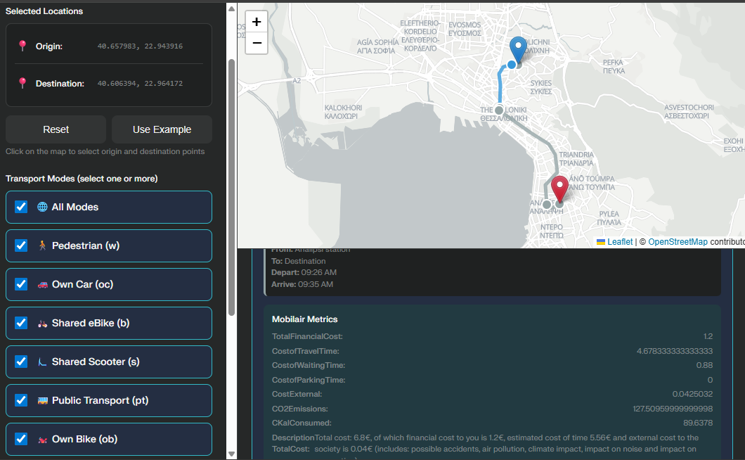
Figure 5: Multimodal Trip Planner internal testbed
Results individualization (TBD)
Each itinerary includes a comprehensive total cost that considers the previously presented key factors.
However, to better match diverse user preferences, the service will be enhanced by internally sorting and ranking itineraries using a separate primary metric: a customizable generalized cost score.
For incorporating individual preferences in the utility function, an additional ranking mechanism that will be based on previous research carried by CERTH in the UPPER TES_05 (https://www.upperprojecteu.eu/wp-content/uploads/2025/03/TES_05_Measure-development.pdf) will be developed. This mechanism will consider each user’s preferred modes of transport as they gathered via the feedback those users provided in the Mobilair app. The final form of the utility function that will be used is the following:
GC_{i} = - 0.18 × $f_{ci}$× ${tt}_{c}$ - 0.236 × $f_{bi}$× ${tt}_{b}$ - 0.37 × $f_{si}$× ${tt}_{s}$ - 0.275 × ${tt}_{w}$ - 0.314 × ${tt}_{pt}$ - 1.073 × c - 3.925 × nt
where:
- ${tt}_{c}$, ${tt}_{b}$, ${tt}_{s}$, ${tt}_{w}, {tt}_{pt}$ is the travel time with shared car, bike, scooter, walk and public transport respectively,
- c is the total cost of trip,
- nt is the number of transfers between different modes.
The adaptation factors (f_{c}, f_{b}, f_{s}) will be computed separately for each user i and they will dynamically be recomputed as the user makes new trips. The three adaptation factors will be calculated using the following steps:
Step 1: calculate adaptation factors for each separate historically preferred trip
i) if it is a car trip:
f_{c1} = $\frac{t_{b}}{t_{c}}$ , if $\frac{t_{b}}{t_{c}}$ > 1 then cap f_{c1} to 1
f_{c2} = $\frac{t_{s}}{t_{c}}$ , if $\frac{t_{s}}{t_{c}}$ > 1 then cap f_{c2} to 1
f_{c3} = $\frac{Tw}{t_{c}}$ , if $\frac{t_{w}}{t_{c}}$ > 1 then cap f_{c3} to 1
f_{c4} = $\frac{Tpt}{t_{c}}$ , if $\frac{t_{pt}}{t_{c}}$ > 1 then cap f_{c4} to 1
ii) if it is a bike trip:
f_{b1} = $\frac{t_{c}}{t_{b}}$ , if $\frac{t_{c}}{t_{b}}$ > 1 then cap f_{b1} to 1
f_{b2} = $\frac{t_{s}}{t_{b}}$ , if $\frac{t_{s}}{t_{b}}$ > 1 then cap f_{b2} to 1
f_{b3} = $\frac{t_{w}}{t_{b}}$ , if $\frac{t_{w}}{t_{b}}$ > 1 then cap f_{b3} to 1
f_{b4} = $\frac{t_{pt}}{t_{b}}$ , if $\frac{t_{pt}}{t_{b}}$ > 1 then cap f_{b4} to 1
iii) if it is a scooter trip:
f_{s1} = $\frac{t_{c}}{t_{s}}$ , if $\frac{t_{c}}{t_{s}}$ > 1 then cap f_{s1} to 1
f_{s2} = $\frac{t_{b}}{t_{s}}$ , if $\frac{t_{b}}{t_{s}}$ > 1 then cap f_{s2} to 1
f_{s3} = $\frac{t_{w}}{t_{s}}$ , if $\frac{t_{w}}{t_{s}}$ > 1 then cap f_{s3} to 1
f_{s4} = $\frac{t_{pt}}{t_{s}}$ , if $\frac{t_{pt}}{t_{s}}$ > 1 then cap f_{s4} to 1
where t_{c}, t_{b}, t_{s,} t_{w,} t_{pt} correspond to the travel time that is needed with car, bike, scooter, walking and public transport for a trip from the origin to the destination of the specific historically preferred trip.
Step 2: calculate adaptation factors for each user
f_{ci} = $\frac{\sum_{j\text{=}1}^{n}{(fc1j\text{+}fc2j\text{+}fc3j\text{+}fc4j)}}{n}$
f_{bi} = $\frac{\sum_{j\text{=}1}^{n}{(fb1j\text{+}fb2j\text{+}fb3j\text{+}fb4j)}}{n}$
f_{si} = $\frac{\sum_{j\text{=}1}^{n}{(fs1j\text{+}fs2j\text{+}fs3j\text{+}fs4j)}}{n}$
where n is the number of trips that the user i carried out with the specific mode.
Car Routing algorithm to minimize environmental air pollution exposure (TBD)
OTP's car mode primarily optimizes for distance and time using static OSM road data without native support for dynamic factors like air quality zones or low-emission restrictions, critical factors for sustainable urban mobility in dense Greek cities. For this reason, in the case of car routing, the aggregation service will be set to bypass OpenTripPlanner entirely in favor of a custom-developed solution to be integrated directly at the service layer.
This alternative car routing algorithm computes vehicle routes that account for both travel distance and environmental air pollution exposure. The method combines road network topology with spatially resolved environmental data to construct a weighted graph representation suitable for environmentally aware routing.
The road network of Thessaloniki was obtained from OpenStreetMap using the OSMnx Python library. During the download process, OSMnx automatically performs the necessary topological preprocessing to construct a routable graph representation. This includes identifying intersections, generating graph nodes and edges, standardizing geometries, and enforcing consistent connectivity. The resulting structure is a fully connected node–edge graph suitable for shortest-path computations. This graph forms the foundation of the routing algorithm by providing the network topology over which shortest-path computations are performed.
Environmental pollution data are provided by the Aristotle University of Thessaloniki at hourly temporal resolution. These datasets consist of raster maps (GeoTIFF format) representing the spatial distribution of major air pollutants, including PM_{2.5}, PM₁₀, NO₂, O₃, and CO. All raster layers share a common coordinate reference system and spatial resolution, ensuring direct spatial compatibility with the road network. The pollutant concentration fields for PM_{2.5}, PM₁₀, NO₂, and O₃ are additionally used to compute a continuous Air Quality Index (AQI) compatible with the European Air Quality Index (EAQI) framework. While the official EAQI is defined using discrete concentration thresholds and categorical classes, the routing service employs a continuous surrogate index that preserves the EAQI structure while ensuring continuity of the cost surface required for routing.
Pollutant concentrations and AQI values are assigned to the road network by spatially sampling the raster fields at node locations. For each environmental indicator, the value at a node is defined as the value of the raster cell whose center is geographically closest to the node coordinates. For each edge connecting two adjacent nodes, a representative indicator value is computed as the arithmetic mean of the values at its endpoints. The geometric length of each edge is obtained directly from the attributes generated by OSMnx, which calculates and stores edge lengths during graph construction. Environmental exposure along each road segment is then quantified by defining an exposure cost equal to the product of the representative indicator value and the edge length. These exposure costs are assigned as edge weights in the routing graph and form the basis for environmentally aware car routing, enabling the computation of paths that minimize pollution exposure in addition to or instead of travel distance. In cases where indicator values exceed predefined thresholds, additional penalties may be applied to the corresponding nodes or edges by increasing their traversal cost, thereby reducing the likelihood that routing paths will pass through highly polluted areas while preserving overall network connectivity.
The routing problem is formulated as a shortest-path optimization on the weighted graph, where edge weights represent environmental exposure cost, geometric distance, or a configurable combination of both. Shortest paths are computed using Dijkstra’s algorithm, which guarantees optimal solutions for graphs with non-negative edge weights. This formulation supports environmentally aware car routing, allowing the selection of routes that minimize exposure to air pollution, either in addition to or instead of travel distance.

3. AI Algorithms

3.1 Objective and solution architecture
The nudging module aims to reduce trip related CO₂ emissions by influencing how route alternatives are presented and described. The module operates on top of a multimodal trip planner. It assigns a behavioral nudge to each alternative and selects the presentation order of the alternatives in the user interface. It then provides these assignments to a Large Language Model module that generates short, personalized text for each alternative.
The runtime sequence is as follows. A user provides an origin and a destination. The multimodal trip planner returns a finite set of feasible itineraries for the requested trip. The nudging optimizer selects one nudge category for each itinerary and selects the screen position of each itinerary, for example top, middle, or bottom. The selected configuration is passed to the LLM module together with the user profile and the itinerary attributes. The LLM module returns UI ready text under a fixed JSON schema.
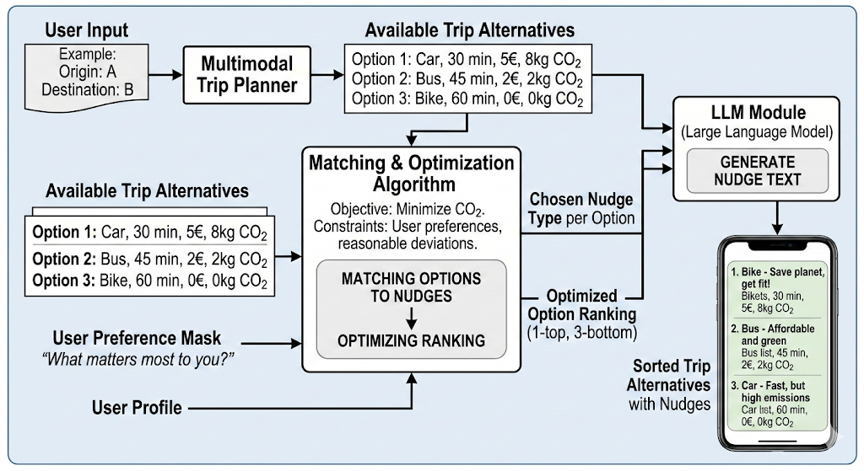
Figure 6
Input and data structures
Alternatives returned by the multimodal trip planner
For each trip request, the trip planner returns a small set of alternatives $I$, typically between three and six. Each alternative $i∈I$is represented by a vector of attributes $x_{i}$. The implementation aggregates leg level information into trip level indicators and stores both core impedance indicators and environmental indicators.
The core indicators include travel time, distance, waiting time, walking time, number of transfers, and a mode sequence descriptor. The cost indicators include total financial cost, when available. The environmental and health indicators include CO₂ emissions and calories consumed.
User profile and preference mask
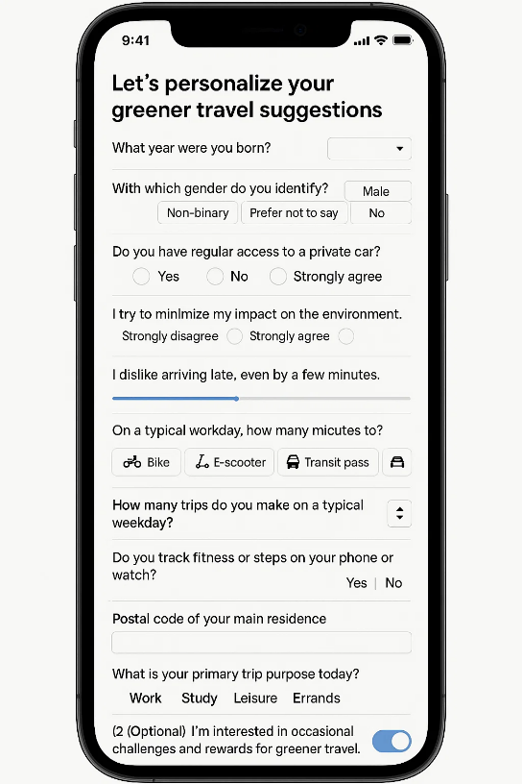
The nudging module uses profile information collected at registration. The profile is mapped to two compact representations that are used online. The first representation is a preference weight vector $w_{u}$over decision dimensions such as time, cost, convenience, reliability, environment, and health. The second representation is a feature vector $z_{u}$that captures behavioural relevant attributes, such as car habit, flexibility, and activity level.

The preference weight vector is derived from the question “What matters most to you when choosing how to travel”. The values are normalized to sum to one. The feature vector is derived from categorical answers and is encoded using binary or ordinal fields. The module also stores motivators and personal goals as tags that are used for text personalization in the LLM module.
Nudge taxonomy and constraints for feasibility
Mobilair uses a finite library of nudge categories. Each category corresponds to an established behavioral mechanism and a defined UI treatment. The taxonomy is deliberately small to support robust evaluation, consistent user experience, and manageable governance.
Nudge category (behavioral principle) | Why it works (psychology) | Typical implementation in a mobility UI
Default / status-quo bias | Users often keep the pre-selected option | Pre-select the greenest option unless user changes it
Framing & loss aversion | Losses loom larger than gains | “Car adds +X g CO₂” vs “Green route saves X g CO₂”
Anchoring / reference points | Early numbers become reference points | Compare to weekly CO₂ guideline or user baseline
Social proof / descriptive norms | Users follow what “most people” do | “74% chose this option last week at this hour”
Salience & visual cues | Vivid cues attract attention | Color bands, icons, bold key metric (CO₂ /kcal)
Commitment & consistency | Commitments increase follow-through | “Prefer green if ≤ 5 min slower” pledge
Feedback, goals & gamification | Feedback sustains motivation | weekly CO₂ savings, streaks, progress rings

The optimizer uses feasibility rules to prevent invalid or misleading messaging. For example, social proof nudges are only allowed when reliable reference statistics exist for the relevant context. Commitment nudges are only allowed when the user has opted in to that interaction type. Nudges that depend on cost information are only allowed when cost is available for the itinerary.
+++ TBC I ll add more

3.2 Methodological Approach of AI nudging recommendation engine
The approach consists of three sequential steps. First, the system reduces the candidate alternatives returned by the trip planner using a travel time filter. Second, it ranks the remaining alternatives using a composite score that combines user stated preferences and trip attributes. Third, it assigns a behavioural nudge focus to each alternative using rule-based personalization derived from user goals and preference weights.
The method is designed to be transparent and computationally efficient. It also ensures that the resulting ranking remains intuitive to the user because the fastest options are always considered first. At the same time, environmental and health attributes can influence the final ranking when the user preferences support such alternatives.
The multimodal trip planner may generate several alternatives that differ in mode combinations, travel time, transfers, and cost. Presenting a large number of alternatives may reduce usability and introduce noise in the ranking procedure. For this reason, the system applies an initial filtering step based on travel time.
Let $I$denote the set of alternatives returned by the trip planner. Each alternative $i∈I$has an associated travel time $t_{i}$. The system selects the three fastest alternatives according to the following rule:
$$I^{\left(3\right)}\text{=}argmin\underset{J⊆I,|J|\text{=}3}{⁡}\sum_{i∈J}{t_{i}}$$
This operation returns the subset $I^{\left(K\right)}$that contains the $K$alternatives with the lowest travel time values. The choice of $K\text{=}3$balances information richness with interface simplicity. The user receives a manageable number of options while the system still considers multiple mobility modes.
To illustrate the methodology below presented an example trip from tripplanner output, the travel times are as follows:
Table 4: example trip plan XXX
Trip ID | Main Mode | Travel Time (min) | CO₂ (g) | Cost (€) | Calories
Trip 0 | Car | 7.9 | 533.58 | 0.74 | 0
Trip 1 | Walk + Bus + Walk | 26.6 | 152.13 | 0.60 | 86.9
Trip 2 | Walk | 51.5 | 0 | 0 | 264.9
Trip 3 | Bicycle | 35.7 | 0 | 0 | 94.6
Trip 4 | Walk + Bicycle | 86.3 | 0 | 10.36 | 194.3
Trip 5 | Walk + Scooter | 69.3 | 0 | 6.96 | 194.3
Trip 6 | Walk + Bus + Bicycle | 77.3 | 120.59 | 10.96 | 82.4
Trip 7 | Walk + Bus + Scooter | 60.3 | 120.59 | 7.56 | 82.4

After applying the travel time filter, the candidate set becomes:
$$I^{\left(3\right)}\text{=}\{\text{Trip 0},\text{Trip 1},\text{Trip 3}\}$$
These correspond to the car, public transport, and bicycle alternatives respectively.
During registration, users are asked to indicate the relative importance of several travel decision criteria. The example preference profile is shown below.
Decision Criterion | User Weight
Time | 4
Cost | 2
Comfort | 1
Convenience | 1
Reliability | 1
Environment | 1
Health | 1

Not all these dimensions are directly available from the trip planner output. Therefore, the method maps each criterion to a measurable proxy derived from the itinerary attributes.
Preference Dimension | Proxy Variable | Description
Time | $$t_{i}$$ | Total travel time
Cost | $$c_{i}$$ | Financial travel cost, Parking Cost
Comfort | $$w_{i}$$ | Walking time
Convenience | $$r_{i}$$ | Number of transfers
Reliability | $$l_{i}$$ | Number of legs in the itinerary
Environment | $$e_{i}$$ | CO₂ emissions
Health | $$h_{i}$$ | Calories burned

These proxies allow the system to approximate user preferences using available data from the trip planner. When a proxy has identical values across all alternatives, it does not influence the ranking because normalization removes its effect.
The different attributes used in the ranking have different units and scales. Travel time is measured in minutes, cost in euros, and emissions in grams of CO₂. To combine them into a single score, the system applies min max normalization within the candidate set $I^{\left(K\right)}$.
For attributes where lower values are preferred, such as travel time or cost, the normalized value is defined as:
$${\hat{x}}_{i,m}\text{=}\frac{x_{i,m}\text{-}min\underset{k∈I^{\left(K\right)}}{⁡}x_{k,m}}{max\underset{k∈I^{\left(K\right)}}{⁡}x_{k,m}\text{-}min\underset{k∈I^{\left(K\right)}}{⁡}x_{k,m}\text{+}ϵ}$$
The parameter $ϵ$is a small constant used to avoid division by zero.
Health is treated differently because higher calorie expenditure indicates greater physical activity. To integrate it into the scoring framework, the system converts it into a disutility measure:
$${\hat{x}}_{i,\text{health}}\text{=}1\text{-}\frac{h_{i}\text{-}min\underset{k∈I^{\left(K\right)}}{⁡}h_{k}}{max\underset{k∈I^{\left(K\right)}}{⁡}h_{k}\text{-}min\underset{k∈I^{\left(K\right)}}{⁡}h_{k}\text{+}ϵ}$$
After normalization, all attributes lie in the interval $[0,1]$. A lower value indicates a more favorable outcome. The overall ranking score for each alternative is computed as a weighted average of the normalized attributes:
$$S_{i}\text{=}\frac{\sum_{m∈M}{w_{m}}{\hat{x}}_{i,m}}{\sum_{m∈M}{w_{m}}}$$
where $w_{m }$represents the user importance weight for dimension $m$. The alternative with the lowest score is considered the most consistent with the user's stated preferences. The table below illustrates the normalized attributes for the three fastest alternatives.
Trip | Mode | Time | Cost | Walking | Legs | CO₂ | Health
Trip 0 | Car | 0.00 | 1.00 | 0.00 | 0.00 | 1.00 | 1.00
Trip 1 | Bus | 0.67 | 0.81 | 1.00 | 1.00 | 0.29 | 0.08
Trip 3 | Bicycle | 1.00 | 0.00 | 0.00 | 0.00 | 0.00 | 0.00

In this example, the car option performs best in travel time but performs poorly in environmental impact. The bicycle option has the lowest environmental and health disutility but requires a longer travel time. The final ranking reflects the balance between these competing criteria according to the user preference weights.
To ensure stable behavior, the system also defines a tie breaking rule. When the difference between two scores is below a small threshold $δ$, the ranking is resolved using CO₂ emissions as the secondary criterion. This encourages environmentally favourable options when user preferences produce near equal scores.
The cold start system does not yet estimate behavioural response parameters. Instead, it assigns nudges using rule-based logic that combines user goals and attribute advantages.
Users are asked to select personal goals during registration. These goals represent motivational factors that can support behavioural change.
Personal Goal | Nudge Emphasis
Improve fitness or physical activity | Health benefits
Live more sustainably | CO₂ reduction
Save money | Financial savings
Improve work life balance | Faster and more predictable travel
Have more relaxation time | Reduced walking and simpler routes
Spend more time with family | Reliable arrival time
Focus on career or work | Time efficiency

For each alternative, the system calculates the advantage of that option relative to the average performance across the candidate set:
$$A_{i,m}\text{=}\overset{´}{{\hat{x}}_{⋅,m}}\text{-}{\hat{x}}_{i,m}$$
A positive value indicates that the alternative performs better than the average on that dimension. The algorithm then selects the nudge focus using two conditions. First, the dimension must belong to the user’s most important preference categories after goal adjustments. Second, the advantage value must exceed a predefined threshold. If no dimension satisfies both conditions, the system selects the dimension with the largest advantage. This ensures that each alternative receives a meaningful message. Applying this logic to the example scenario produces the following nudge assignment:
Trip | Mode | Nudge Focus | Example Message
Trip 0 | Car | Time saving | Fastest option with the shortest travel time
Trip 1 | Bus | Environmental impact | Reduces emissions compared with driving
Trip 3 | Bicycle | Health benefit | Burns calories and improves physical activity

The selected focus and supporting metrics are passed to the language model module. The language model then generates a concise message for each alternative, such as “This option reduces emissions by approximately 380 g CO₂ compared with driving” or “Cycling burns around 95 kcal while producing zero emissions”.

4. Mobile Application (R2.5.2)

4.1 Application Overview
The MobilAir mobile application provides the user a portal to all the features that will aid them in their sustainable and green mobility choices while earning points that can be exchanged for various gifts.
The application will be available for iOS and Android devices through the App Store and Play Store respectively.
The users must create an account that requires email verification in order to access the features of the application.
The application communications will be transferred over secure and encrypted HTTPS protocol thus ensuring the protection of the personal data of the users.

4.2 Application Features & Screenshots
The Mobilair mobile application consists of user-friendly, modern and easy-to-use interface. It was developed using React Native ensuring a common UI experience on both major OS platforms (Android and iOS). The main features of the application are described below.

User authentication
The application provides the necessary user management services that can be used for account creation (registration) and logging in for full feature access. During the registration the user must enter a valid email address, a password and agreement to the terms and conditions. As a last step, the user must verify the provided email address for the account to be enabled.

On-boarding survey
The first time the user logs in into the application, they must complete the on-boarding survey where they must answer a series of questions. These questions will be used to construct a personalized profile of the user and are a vital part of the nudging system.

Air Quality
Similarly, with the display described above, the user can have access to a qualitative value of the air quality in the area (e.g. “Very Good”, “Good” etc) along with a corresponding colour.

Eco-routing
In this feature, the user can provide the origin and destination of their desired trip and view alternatives based on CO2 and money cost across different modes of transport. The user can select a trip and view all the details regarding the route, cost and CO2 consumption. If the user selects the car option, the application provides the most eco-friendly route available.

Level progress, eco-coins and gifts
In this screen, the user can view the progress regarding their level, view their accumulated eco-coins and the available gifts. Here they can also spend their eco-coins to receive a gift of their choice.

Gift redemption
The received gifts are displayed in this section of the application. Through here the user can redeem their bought gifts by presenting the unique QR code to the competent business.

Quizzes and Surveys
This application screen, provides a list of the available quizzes and surveys the user can answer. Completing a quiz or a survey the user collects points that go towards levelling up.
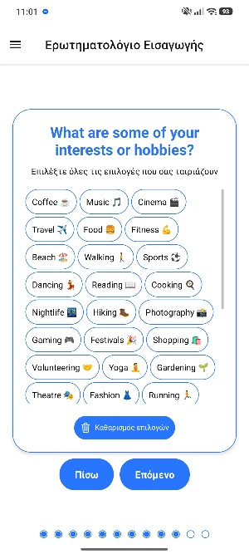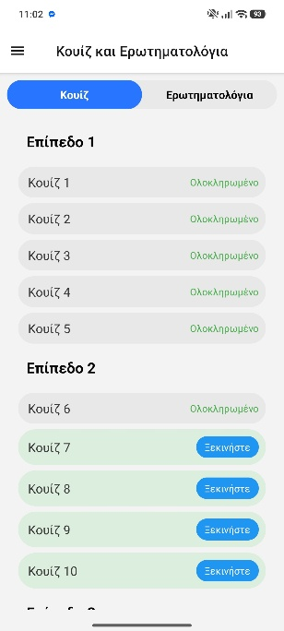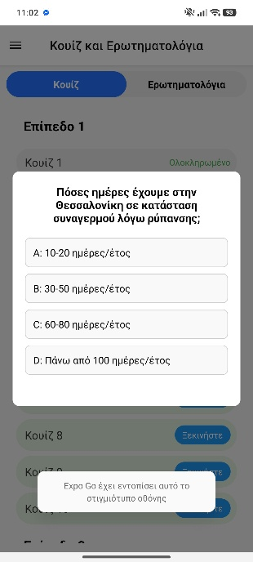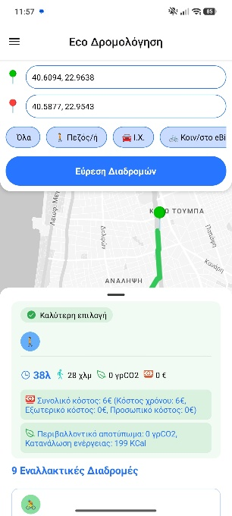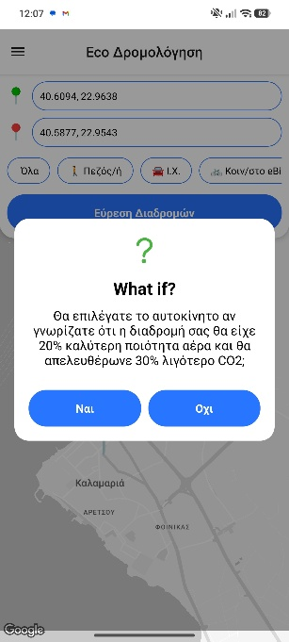
Figure 7 From left to right: (i) Example of on-boarding survey question, (ii) Air quality screen, (iii) Eco routing example, (iv) Level and points screen, (v) Quiz and surveys screen, (vi) Quiz example, (vii) Survey example, (viii) What-if question example (nudging)

References
Ayvens. (2025). Ayvens Car Cost Index 2025. Ayvens. https://www.ayvens.com/-/media/ayvens/public/shared/documents/ayvens-car-cost-index-2025---march-2025.pdf

FIA Region I. (2022). EU Fleet TCO Analysis: Total Cost of Ownership of Passenger Cars. FIA Region I. https://www.fiaregion1.com/wp-content/uploads/2022/11/FIA_Study_CostofOwnership.pdf

Eurostat. (2025). Passenger Cars in the EU. Statistics Explained, European Commission. https://ec.europa.eu/eurostat/statistics-explained/index.php/Passenger_cars_in_the_EU

[Author(s) not specified]. (n.d.). Transportation Development Study for the Thessaloniki Metro.

Kehlbacher, A., Rybczak, G., Rauch, F., & Hellekes, J.. (2025). Estimating Parking Search Times for Transport Modelling in Europe: A Hierarchical Bayes Approach with Cross-Regional Data Integration. hEART 2025 – 13th Symposium of the European Association for Research in Transportation, Munich, Germany. https://www.researchgate.net/publication/392778310_Estimating_Parking_Search_Times_for_Transport_Modelling_in_Europe_A_Hierarchical_Bayes_Approach_with_Cross-Regional_Data_Integration

CE Delft / Ricardo. (2019). Handbook on the External Costs of Transport, Version 2019 – 1.1. European Commission, DG MOVE. https://www.infras.ch/media/filer_public/fc316665-e114-4514-bbca-ede593d2290f/ce_delft_4k83_task_d_summary_report.pdf

Muncrief, R.. (2017). Euro VI versus Euro 6: Differences in Real-World Effectiveness. International Council on Clean Transportation (ICCT). https://theicct.org/sites/default/files/publications/Euro-VI-versus-6_ICCT_briefing_06012017.pdf

Car and Motor. (n.d.). Αυξήθηκαν οι μέσες εκπομπές CO₂ στην Ελλάδα [Average CO₂ Emissions in Greece Have Increased]. carandmotor.gr. https://www.carandmotor.gr/nea/ayxithikan-oi-meses-ekpompes-co2-stin-ellada

